EN55022 / CISPR 22 / AS/NZS 3548
CLASS B

EMI TEST REPORT

of

Personal Computer

Model/ Type/ Machine Type

VT3200

Applied by:

Acer Inc.
7 Hsin Ann Rd., Science-Based Industrial Park
Hsinchu 30077
Taiwan, R. O. C.

Test Performed by:
(NVLAP Lab. Code: 200234-0)
International Standards Laboratory
No. 21, Alley 37, Lane 122, Sec. 2
Hsiwan Rd. Hsichih Chen
Taipei Hsien 22117
Taiwan, R.O.C.

Tel:(02)2646-2550
Fax:(02)2646-4641

Contents of Report
1. General 1
1.1 Certification of Accuracy of Test Data 1
1.2 Summary 2
2. Powerline Conducted Emissions 4
2.1 Configuration and Procedure 4
2.2 Test Data: CPU: Pentium III 1000 MHz, SPS: SPI (Model: FSP145-60SA) 145W, Hard Disk Driver: Seagate (Model: ST330620A) 30GB, Resolution: 1280X1024 V: 60Hz 5
3. Open Field Radiated Emissions 7
3.1 Configuration and Procedure 7
3.2 Test Data:.CPU: Pentium III 1000 MHz, SPS: SPI (Model: FSP145-60SA) 145W, Hard Disk Driver: Seagate (Model: ST330620A) 30GB, Resolution: 1280X1024 V: 60Hz 8
4. Appendix 10
4.1 Appendix A: Measurement Procedure for Powerline Conducted Emissions 10
4.2 Appendix B: Test Procedure for Radiated Emissions 11
4.3 Appendix C: Test Equipment 12
4.4 Appendix D: Layout of EUT and Support Equipment 14
4.5 Appendix E: Description of Support Equipment 16
4.6 Appendix F: Description of Equipment Under Test 23
4.7 Appendix G: Photographs of EUT Configuration Test Set Up 25

General

Certification of Accuracy of Test Data

The electromagnetic interference tests which this report describes were conducted by an independent electromagnetic compatibility consultant, International Standards Laboratory in accordance with the EN55022:1994 /A1:1995 /A2: 1997; CISPR 22:1993/A1:1995/A2:1996; AS/NZS 3548:1995 /A1:1997 /A2:1997 test Procedure.

The test results contained in this report accurately represent the radiated and power line conducted electromagnetic emissions generated by sample equipment under test at the time of the test.

Equipment Tested: Personal Computer
Model/ Type/ Machine Type: VT3200
Applied by Acer Inc.
Date of test: 2001/02/12
Temperature 20ºC(Conduction Test); 18ºC (Radiation Test)
Humidity: 53% (Conduction Test); 95% (Radiation Test)

Test Engineer: Alan Tsai

The results show that the sample equipment tested as described in this report is in compliance with the Class B conducted and radiated emission limits of EN55022:1994 /A1:1995 /A2: 1997; CISPR 22:1993/A1:1995/A2:1996; AS/NZS 3548:1995 /A1:1997 /A2:1997 regulations.

Approve & Signature



---------------------------------------
L. Y. Soong/Director

Note: This test report shall not be reproduced except in full, without the written approval of International Standards Laboratory

Summary

Description of Equipment Under Test (EUT)

Description: Personal Computer
Model/ Type/ Machine Type: VT3200
Applicant: Acer Inc.
7 Hsin Ann Rd., Science-Based Industrial Park
Hsinchu 30077
Taiwan, R. O. C.
A more detailed, technical description of the EUT is contained in Appendix E

Description of EUT and Support Equipment Included in Tests

The EUT is a Personal Computer (Model/ Type/ Machine Type: VT3200), which was tested with the following support units:

- Acer Digital Camera Model: DVC-VII
- Acer USB Mouse Model: MUSXT
- Acer USB Keyboard Model: 6511-P
- Microsoft Joy Stick Model: 90873
- Andrea Headphone Model: NC-80
- Koka Headphone Model: ST-8
- KOKA Microphone Model: DM-510
- KOKA Microphone Model: DM-510
- SONY radio cassette player Model: WM-FX50
- HP Printer Model: 2225C
- Logitech Mouse Model: M-S34
- Aceex Modem Model: DM1414
- Acer Monitor Model: 7377xe
- Acer Keyboard Model: 6511-TW4C
- IBM Personal Computer Model: IBM2170
- Acer USB Speaker Model: A-1
A more detailed technical description of the support equipment is contained in Appendix E.

Test Procedure and Specification

The tests were performed in accordance with EN55022:1994 /A1:1995 /A2: 1997; CISPR 22:1993/A1:1995/A2:1996; AS/NZS 3548:1995 /A1:1997 /A2:1997 regulations as detailed in the Appendix A & B and the individual test sections. The test instrument used is detailed in Appendix A. The specification used was the Class B limits of EN55022:1994 /A1:1995 /A2: 1997; CISPR 22:1993/A1:1995/A2:1996; AS/NZS 3548:1995 /A1:1997 /A2:1997 regulations.

Tests Performed

1. Powerline conducted emissions in shielded room.
See Part 2 of this report for full details.
2. Radiated emissions in 10 meter open area.
See Part 3 of this report for full details.

Powerline Conducted Emissions

Configuration and Procedure

EUT Configuration

The equipment under test was set up in the shielded room with the EUT 40cm away from the wall of the room. The EUT was placed on a non-conductive test table which is 80cm in height. Excess power cord was folded back and forth to form a 30cm by 40cm bundle. The distance between EUT and LISN is 80cm.

Any changes made to the configuration, or modifications made to the EUT, during testing are noted in the following test record.

Test Procedure

The system was set up as described above, with the EMI diagnostic software running. The powerline conducted EMI tests were run on the hot and neutral conductors of the power cord and the results were recorded. The effect of varying the position of the interface cables has been investigated to find the configuration that produces maximum emission.

At the frequencies where the peak values of the emissions were higher than 6dß below the applicable limits, the emissions were also measured with the quasi-peak detectors. At the frequencies where the quasi-peak values of the emissions were higher than 6dß below the applicable average limits, the emissions were also measured with the average detectors.

The highest emissions were analyzed in details by operating the spectrum analyzer in fixed tuned mode to determine the nature of the emissions and to provide information which could be useful in reducing their amplitude.

EMI Receiver/Spectrum Analyzer Configuration (for the frequencies tested)

Frequency Range: 150KHz--30MHz
Detector Function: Quasi-Peak / Average Mode
Bandwidth (RBW): 9KHz

Test Data: CPU: Pentium III 1000 MHz, SPS: SPI (Model: FSP145-60SA) 145W, Hard Disk Driver: Seagate (Model: ST330620A) 30GB, Resolution: 1280X1024 V: 60Hz

Table 2.2.1 Power Line Conducted Emissions (Hot)
 |  | LISN |  | Quasi-Peak |  |  |  |  |  | Average
Frequency  (KHz/MHz) |  | Insertion Loss  (dB) |  | Amplitude  (dBuV) |  | Limit  (dBuV) |  | Margin  (dB) |  | Amplitude  (dBuV) |  | Limit  (dBuV) |  | Margin  (dB)
205.30KHz | 0.20 |  | 39.60 |  | 64.42 |  | -24.62 |  | 38.19 |  | 54.42 |  | -16.03
332.45KHz | 0.20 |  | 32.48 |  | 60.79 |  | -28.11 |  | 28.62 |  | 50.79 |  | -21.96
487.28KHz | 0.20 |  | 41.36 |  | 56.36 |  | -14.80 |  | 38.82 |  | 46.36 |  | -7.34
514.38KHz | 0.20 |  | 35.64 |  | 56.00 |  | -20.16 |  | 31.77 |  | 46.00 |  | -14.03
628.23KHz | 0.20 |  | 30.34 |  | 56.00 |  | -25.46 |  | 21.58 |  | 46.00 |  | -24.22
713.75KHz | 0.20 |  | 34.04 |  | 56.00 |  | -21.76 |  | 28.44 |  | 46.00 |  | -17.36
786.10KHz | 0.20 |  | 39.75 |  | 56.00 |  | -16.05 |  | 38.35 |  | 46.00 |  | -7.45
860.55KHz | 0.20 |  | 38.11 |  | 56.00 |  | -17.69 |  | 33.79 |  | 46.00 |  | -12.01
935.83KHz | 0.20 |  | 37.42 |  | 56.00 |  | -18.38 |  | 35.10 |  | 46.00 |  | -10.70
6.8059MHz | 0.44 |  | 30.02 |  | 60.00 |  | -29.54 |  | 21.45 |  | 50.00 |  | -28.11
13.602MHz | 0.74 |  | 16.63 |  | 60.00 |  | -42.63 |  | 9.05 |  | 50.00 |  | -40.20
14.639MHz | 0.79 |  | 21.46 |  | 60.00 |  | -37.75 |  | 17.12 |  | 50.00 |  | -32.10
18.679MHz | 0.95 |  | 19.44 |  | 60.00 |  | -39.61 |  | 11.58 |  | 50.00 |  | -37.47
24.264MHz | 0.83 |  | 10.11 |  | 60.00 |  | -49.06 |  | 3.47 |  | 50.00 |  | -45.70

* NOTE: Margin = Amplitude + Insertion Loss- Limit
A margin of -8dB means that the emission is 8dB below the limit


Tested by:

_________________________
Alan Tsai
Table 2.2.1 Power Line Conducted Emissions (Neutral)
 |  | LISN |  | Quasi-Peak |  |  |  |  |  | Average
Frequency  (KHz/MHz) |  | Insertion Loss  (dB) |  | Amplitude  (dBuV) |  | Limit  (dBuV) |  | Margin  (dB) |  | Amplitude  (dBuV) |  | Limit  (dBuV) |  | Margin  (dB)
203.13KHz | 0.20 |  | 38.97 |  | 64.48 |  | -25.31 |  | 36.57 |  | 54.48 |  | -17.71
307.25KHz | 0.25 |  | 35.95 |  | 61.51 |  | -25.30 |  | 34.31 |  | 51.51 |  | -16.95
415.63KHz | 0.30 |  | 34.04 |  | 58.41 |  | -24.07 |  | 28.37 |  | 48.41 |  | -19.74
492.13KHz | 0.30 |  | 35.42 |  | 56.22 |  | -20.51 |  | 32.39 |  | 46.22 |  | -13.53
604.75KHz | 0.30 |  | 34.09 |  | 56.00 |  | -21.61 |  | 28.24 |  | 46.00 |  | -17.46
645.13KHz | 0.30 |  | 31.83 |  | 56.00 |  | -23.87 |  | 28.94 |  | 46.00 |  | -16.76
681.25KHz | 0.30 |  | 27.80 |  | 56.00 |  | -27.90 |  | 19.68 |  | 46.00 |  | -26.02
764.13KHz | 0.30 |  | 23.77 |  | 56.00 |  | -31.93 |  | 18.32 |  | 46.00 |  | -27.38
798.13KHz | 0.30 |  | 30.63 |  | 56.00 |  | -25.07 |  | 27.42 |  | 46.00 |  | -18.28
949.00KHz | 0.30 |  | 22.79 |  | 56.00 |  | -32.91 |  | 16.26 |  | 46.00 |  | -29.44
1.2175MHz | 0.30 |  | 24.31 |  | 56.00 |  | -31.39 |  | 18.68 |  | 46.00 |  | -27.02
11.440MHz | 0.50 |  | 19.17 |  | 60.00 |  | -40.33 |  | 14.03 |  | 50.00 |  | -35.47
18.907MHz | 0.50 |  | 15.06 |  | 60.00 |  | -44.44 |  | 6.31 |  | 50.00 |  | -43.19

* NOTE: Margin = Amplitude + Insertion Loss- Limit
A margin of -8dB means that the emission is 8dB below the limit
Tested by:

_________________________
Alan Tsai

Open Field Radiated Emissions

Configuration and Procedure

EUT Configuration

The radiated emissions test setups are in accordance with EN55022:1994 /A1:1995 /A2: 1997; CISPR 22:1993/A1:1995/A2:1996; AS/NZS 3548:1995 /A1:1997 /A2:1997.

The equipment under test was set up on the 10 meter open field test non-conductive table 80cm above ground, same as conducted Excess data cable was folded back and forth to form a 30cm by 40cm bundle.

Any changes made to the configuration, or modifications made to the EUT, during testing are noted in the following test record.

If the EUT is a Personal Computer or a peripheral of personal computer, and the personal computer has an auxiliary AC outlet which can be used for providing power to an external monitor, then all measurements will be made with the monitor power from first the computer-mounted AC outlet and then a floor-mounted AC outlet.

Test Procedure

The system was set up as described above, with the EMI diagnostic software running. The maximum readings were found by varying the height of antenna and then rotating the turntable. Both polarization of antenna, horizontal and vertical, are measured. The effect of varying the position of the interface cables has been investigated to find the configuration that produces maximum emission.

The highest emissions were also analyzed in details by operating the spectrum analyzer in fixed tuned quasi-peak mode to determine the precise amplitude of the emissions. While doing so, the antenna height was varied between one and four meters, and the turntable was slowly rotated, to maximize the emission.

Spectrum Analyzer Configuration (for the frequencies tested)

Frequency Range: 30MHz--1000MHz
Detector Function: Quasi-Peak Mode
Bandwidth (RBW): 120KHz

Test Data:.CPU: Pentium III 1000 MHz, SPS: SPI (Model: FSP145-60SA) 145W, Hard Disk Driver: Seagate (Model: ST330620A) 30GB, Resolution: 1280X1024 V: 60Hz
Table 3.2.1 Open Field Radiated Emissions (Horizontal)
Meter Reading |  |  | Correction Factor |  |  |  |  |  | Corrected Emissions |  |  |  |  |  |  |  | Antenna |  | Turntable
Freq.  (MHz) | Ampl.  (dBuV) |  | Ant.  (dB/m) |  | Cable  (dB) |  | Pre-Ampl.  (dB) |  | Ampl.  (dBuV/m) |  | Limit  (dBuV/m) |  | Margin*  (dB) |  | Height  (cm) |  |  |  | Position  (°)
99.677 |  | 15.26 |  | 10.35 |  | 1.67 |  | 0.00 |  | 27.28 |  | 30.00 |  | -2.72 |  | 400.00 |  | 300.00
135.01 |  | 11.68 |  | 10.90 |  | 2.08 |  | 0.00 |  | 24.66 |  | 30.00 |  | -5.34 |  | 400.00 |  | 276.00
180.00 |  | 14.25 |  | 8.60 |  | 2.54 |  | 0.00 |  | 25.39 |  | 30.00 |  | -4.61 |  | 400.00 |  | 295.00
399.65 |  | 10.64 |  | 15.79 |  | 3.93 |  | 0.00 |  | 30.35 |  | 37.00 |  | -6.65 |  | 400.00 |  | 195.00
530.28 |  | 6.33 |  | 18.37 |  | 4.59 |  | 0.00 |  | 29.29 |  | 37.00 |  | -7.71 |  | 400.00 |  | 343.00
661.75 |  | 9.49 |  | 19.40 |  | 5.20 |  | 0.00 |  | 34.09 |  | 37.00 |  | -2.91 |  | 400.00 |  | 358.00

* NOTE: Margin = Corrected Amplitude – Limit
Corrected Amplitude = Radiated Amplitude + Antenna Correction Factor + Cable Loss – Pre-Amplifier Gain
A margin of -8dB means that the emission is 8dB below the limit
BILOG Antenna Distance: 10 meter, Frequency: under 1000MHz
Horn Antenna Distance: 3 meter, Frequency: 1000MHz—18GHz

Tested by:

_________________________
Alan Tsai
Table 3.2.2 Open Field Radiated Emissions (Vertical)
Meter Reading |  |  | Correction Factor |  |  |  |  |  | Corrected Emissions |  |  |  |  |  |  |  | Antenna |  | Turntable
Freq.  (MHz) | Ampl.  (dBuV) |  | Ant.  (dB/m) |  | Cable  (dB) |  | Pre-Ampl.  (dB) |  | Ampl.  (dBuV/m) |  | Limit  (dBuV/m) |  | Margin*  (dB) |  | Height  (cm) |  |  |  | Position  (°)
79.972 |  | 16.98 |  | 6.50 |  | 1.55 |  | 0.00 |  | 25.03 |  | 30.00 |  | -4.97 |  | 175.00 |  | 243.00
99.969 |  | 15.19 |  | 10.39 |  | 1.67 |  | 0.00 |  | 27.25 |  | 30.00 |  | -2.75 |  | 100.00 |  | 286.00
165.69 |  | 15.61 |  | 9.07 |  | 2.36 |  | 0.00 |  | 27.04 |  | 30.00 |  | -2.96 |  | 100.00 |  | 20.00
199.97 |  | 15.57 |  | 8.30 |  | 2.69 |  | 0.00 |  | 26.56 |  | 30.00 |  | -3.44 |  | 100.00 |  | 254.00
532.91 |  | 8.46 |  | 18.42 |  | 4.60 |  | 0.00 |  | 31.48 |  | 37.00 |  | -5.52 |  | 100.00 |  | 0.00
666.21 |  | 8.97 |  | 19.40 |  | 5.23 |  | 0.00 |  | 33.60 |  | 37.00 |  | -3.40 |  | 100.00 |  | 205.00

* NOTE: Margin = Corrected Amplitude – Limit
Corrected Amplitude = Radiated Amplitude + Antenna Correction Factor + Cable Loss - Pre-Amplifier Gain
A margin of -8dB means that the emission is 8dB below the limit
BILOG Antenna Distance: 10 meter, Frequency: under 1000MHz
Horn Antenna Distance: 3 meter, Frequency: 1000MHz—18GHz
Tested by:

_________________________
Alan Tsai

Appendix

Appendix A: Measurement Procedure for Powerline Conducted Emissions

The EUT is set up in accordance with the suggested configuration given in EN55022:1994 /A1:1995 /A2: 1997; CISPR 22:1993/A1:1995/A2:1996; AS/NZS 3548:1995 /A1:1997 /A2:1997. The measurements are performed in a 7.6 x 5.7 x 5 (m) shielded room. The EUT was placed on a non-conduction table, which is 0.8 meters above an earth-grounded floor, 0.4 meters in the back away from the metal wall and 0.8 meter at least in the front, left and right away from the metal wall.

Power to the EUT was provided through the LISN which has the Impedance (50 Ohm/50uH) vs. Frequency Characteristic as defined in Sub-clause 8.3.3, Section Two, of CISPR 16. Power to the LISN was filtered to eliminate ambient signal interference and this filter was bonded to ground. Peripheral equipment required to provide a functional system (support equipment) for EUT testing was powered through a ganged, metal power outlet box which is bonded to the ground. AC input power for the auxiliary power outlets was obtained from the same filtered source that provides input power to the LISN.

If the EUT is supplied with a flexible power cord, if the power cord length in excess of 1 m, the excess cable shall be bundled at approximate center of the power cord with the bundles 30 cm to 40 cm in length. If the EUT is provided with a permanently coiled power cord, bundling of the cord is not required. If the EUT is supplied without a power cord, the EUT shall be connected to the LISN by a power cord of the type specified by the manufacturer which shall be 1 meter in length. If a non-flexible power cord is provided with the EUT, it shall be cut to the length necessary to attach the EUT to the LISN and shall not be bundled.

The EUT, any support equipment, and any interconnecting cables were arranged and moved to get the maximum according to EN55022:1994 /A1:1995 /A2: 1997; CISPR 22:1993/A1:1995/A2:1996; AS/NZS 3548:1995 /A1:1997 /A2:1997. Both the line of power cord, hot and neutral, were measured.

The highest emissions were analyzed in details by operating the spectrum analyzer in fixed tuned mode to determine the nature of the emissions and to provide information which could be useful in reducing their amplitude.

Appendix B: Test Procedure for Radiated Emissions

Preliminary Measurements in the Anechoic Chamber

The radiated emissions are initially measured in the anechoic chamber at a measurement distance of 3 meters. Desktop EUTs are placed on a wooden stand 0.8 meter in height. The measurement antenna is 3 meters from the EUT. The test setup in anechoic chamber is the same as open site. The turntable rotated 360°C. The antenna height is varied from 1-2.5m. The primary objective of the radiated measurements in the anechoic chamber is to identify the frequency spectrum in the absence of the electromagnetic environment existing on the open test site. The frequencies can then be preselected on the open test site to obtain the corresponding amplitude. The initial scan is made with the spectrum analyzer in automatic sweep mode. The spectrum peaks are then measured manually to determine the exact frequencies.

Measurements on the Open Site

The radiated emissions test will then be repeated on the open site to measure the amplitudes accurately and without the multiple reflections existing in the shielded room. The EUT and support equipment are set up on the turntable of one of the 3 or 10 meter open field sites. Desktop EUTs are set up on a wooden stand 0.8 meter above the ground.

For the initial measurements, the receiving antenna is varied from 1-4 meter height and is changed in the vertical plane from vertical to horizontal polarization at each frequency. Both reading are recorded with the quasi-peak detector and with the 120 kHz bandwidth. For frequency between 30 MHz and 1000MHz, the reading are recorded with peak detector and with the 1 MHz bandwidth.

At the highest amplitudes observed, the EUT is rotated in the horizontal plane while changing the antenna polarization in the vertical plane to maximize the reading. The interconnecting cables were arranged and moved to get the maximum according to ANSI C63.4-1992, and/or EN55022:1994/A1:1995/A2:1997 / CISPR 22:1993/A1:1995/A2:1996. Once the maximum reading is obtained, the antenna elevation and polarization will be varied between specified limits to maximize the readings.

During the open site measurements, the peaks are selected, the scan frequency span width is reduced to 0--1MHz, the audible modulation is monitored with a loudspeaker and the quasi-peak reading or peak is recorded at the indicated frequency and at the specified bandwidth.

Appendix C: Test Equipment

Test Equipment List

Use  For | Equipment | Brand | Model | Start  Service Date | Last  Cal. Date | Next  Cal. Date
R | EMI Receiver | R&S | ESMI; rev. 02.80  S/N: 849182/003 | Nov. 09, 1999 | Oct. 23, 2000 |  | Apr. 22, 2001
R | EMI Receiver | HP | 8546A;  S/N: 3520A00236 | Oct. 28, 2000 | Oct. 27, 2000 |  | Oct. 27, 2001
R | BILOG Antenna | Chase | CBL6112B  S/N: 2487 | Nov. 23, 1998 | Nov. 03, 2000 |  | Nov. 02, 2001
R | Horn Antenna | EMCO | 3115  S/N: 9504-4462 | Nov. 06, 1999 | Dec. 02, 2000 |  | Dec.01, 2001
R | Coaxial Cables | RICHTEC | TWB4001  S/N: 3F-10 | Aug. 31, 1995 | Jul. 24, 2000 |  | Jul. 24, 2001
R | Coaxial Cables | RICHTEC | 9913 (CB03)  S/N: 3F-3 | Dec. 20, 1998 | Apr. 19, 2000 |  | Apr. 19, 2001
R | Thermo-Hygro Meter | CRECER | HD-30  S/N: ISL-C-001 | Nov. 26, 1999 | Nov. 28, 2000 |  | Nov. 27, 2001
C | EMI Receiver | HP | 8546A;  S/N: 3441A00208 | Sep. 08, 1997 | Dec. 13, 2000 |  | Dec. 13, 2001
C | LISN 1 | R & S | ESH2-Z5  S/N: 890485/013 | Dec. 15, 1988 | Oct. 27, 2000 |  | Oct. 27, 2001
C | LISN 2 | EMCO | 3825/2  S/N: 1407 | Oct. 20, 1990 | Oct. 27, 2000 |  | Oct. 27, 2001
C | Terminator | RICHTEC | S/N: ISL-T-001 | Oct. 19, 1999 | Apr. 29, 2000 |  | Apr. 28, 2001
C | Terminator | RICHTEC | S/N: ISL-T-002 | Oct. 19, 1999 | Apr. 29, 2000 |  | Apr. 28, 2001
C | Coaxial Cables | RICHTEC | RG400  S/N: 1F-C1 | Aug. 31, 1995 | Feb. 28, 2000 |  | Feb. 28, 2001
C | Coaxial Cables | RICHTEC | RG400  S/N: 1F-C2 | Aug. 31, 1995 | Feb. 28, 2000 |  | Feb. 28, 2001
C | Digital Thermo-Hygro Meter | MICROLIFE | S/N: ISL-C-002 | Nov. 26, 1999 | Nov. 28, 2000 |  | Nov. 27, 2001

Note:

Calibration traceable to NIST or national or international standards.

***: The equipment is sent for calibration.
The Use For column with C means the equipment is used for the measurement of conducted emission.
The Use For column with R means the equipment is used for the measurement of conducted emission.
The Use For column with U means the equipment is used as a spare equipment for the measurement when equipment sent for calibration.

Software for Controlling Spectrum/Receiver and Calculating Test Data
Radiation/Conduction | Filename | Version | Issued Date
Conduction | 97CEMI.EXE | 2.0 | 10/8/97
Radiation | 97XEMI.EXE | 3.3 | 3/21/97

Appendix D: Layout of EUT and Support Equipment

General Conducted Test Configuration

Shielded Room

40 cm

Non-Conducted Table

80 cm

Metal Ground Plane

LISN

LISN
Load
Active
EUT
Printer
Spectrum
Control PC
Filter
Filter

General Radiation Test Configuration

10 M

Antenna Mast Broadband or Dipole Antenna Antenna height can be moved from 1 m to 4 m, Antenna and turntable distance 3 m to 10 m.
Non-Conducted
Table
To Spectrum

80 cm To Remote
Controller

To Remote Controller
Load
Active
EUT
Printer
Spectrum
Control PC
Remote
Controller

Metal Full Soldered Ground Plane

To Turntable
To Antenna

To Antenna

Appendix E: Description of Support Equipment

Description of Support Equipment

- Description: Acer USB Speaker
Model Number: A-1
Serial Number: N/A
Power Supply Type: N/A
Power Cord: N/A
FCC ID: (Comply with FCC DOC)
- Description: Acer Digital Camera
Model: DVC-VII
Serial Number: N/A
Power Supply Type: From PC USB Port
Power Cord: N/A
FCC ID: (Comply with FCC DOC)
- Description: Acer USB Mouse
Model Number: MUSXT
Serial Number: 81130159
Power Supply Type: N/A
Power Cord: N/A
FCC ID: (comply with FCC DOC)
- Description: Acer USB Keyboard
Model Number: 6511-P
Serial Number: 9152P0701183I31025S00000
Power Supply Type: N/A
Power Cord: N/A
FCC ID: JVP6511-P
- Description: Microsoft Joy Stick
Model Number: 90873
Serial Number: 01151545
Power Supply Type: N/A
Power Cord: N/A
FCC ID: C3KMGP1
- Description: Andrea Headphone
Model Number: NC-80
Serial Number: N/A
Power Supply Type: N/A
Power Cord: N/A
FCC ID: N/A
- Description: Koka Headphone
Model Number: ST-8
Serial Number: N/A
Power Supply Type: N/A
Power Cord: N/A
FCC ID: N/A
- Description: KOKA Microphone
Model Number: DM-510
Serial Number: N/A
Power Supply Type: N/A
Power Cord: N/A
FCC ID: N/A
- Description: KOKA Microphone
Model Number: DM-510
Serial Number: N/A
Power Supply Type: N/A
Power Cord: N/A
FCC ID: N/A
- Description: SONY radio cassette player
Model Number: WM-FX50
Serial Number: N/A
Power Supply Type: N/A
Power Cord: N/A
- Description: HP Printer
(for parallel interface port)
Model Number: 2225C
Serial Number: N/A
Power Supply Type: Switching
(AC to AC Xfmr, Wall Mounted Type)
Power Cord: Nonshielded, Detachable
With Grounding Pin
FCC ID: DSI6XU2225
- Description: Logitech Mouse
Model Number: M-SAH
Serial Number: LZB81251703
Power Supply Type: N/A
Power Cord: N/A
FCC ID: DZL211029
- Description: Aceex Modem
(for serial interface port)
Model Number: DM1414
Serial Number: 960063771
Power Supply Type: Linear, Power Adapter
( AC to AC Xfmr, Wall Mounted Type )
Power Cord: Nonshielded, Without Grounding Pin
FCC ID: IFAXDM1414
- Description: Acer Monitor
Model: 7377xe
Serial Number: 999027100501700055P644E1 P
Power Supply Type: Switching
Power Cord: Nonshielded, Detachable
FCC ID: (Comply with FCC DOC)
- Description: Acer Keyboard
Model Number: 6511-TW4C
Serial Number: 916600704C83D11076S00000
Power Supply Type: N/A
Power Cord: N/A
FCC ID: JVPKBS-WIN
- Description: Personal Computer
Model: IBM 2170
Serial No.: N/A
Power Supply Type : Switching
Delta (Model: DPS-145PB-80A)
Hard Disk Drive: Maxtor (Model: 91303D6) 13.3GB
Floppy Driver: Panasonic (Model: JU256A276P )
CD-ROM Drive: AOpen (Model: CD-940E/TKU PRO)
ZIP Driver: Iomega (Model:Z100ATAPI)
LAN Card Accton (Model: EN1207D-TX1)
FDD/HDD Controller and
VGA port/ Parallel/
Serial port: Built on Motherboard
VGA port: one 15-pin
Parallel Port: one 25-pin
Serial Port: one 9-pin
Keyboard Connector: 6-pin
Mouse Connector: 6-pin
USB Connector: two 4-pin
Game Port: one 15-pin
Speaker Port: one
Microphone Port: one
Line In Port: one
Power Cord: Nonshielded, Detachable
FCC ID: N/A (comply witch FCC DOC)

Software for Controlling Support Unit
A test program which generates a complete line of continuously repeating "H" pattern is used as the software test program. The program was executed as follows:

- Read and write to the disk drives.
- Send audio signal to the speaker.
- Capture Video image from digital camera than playback to display.
- Send audio signal to the headphone.
- Send audio signal to the headphone.
- Receive audio signal from the microphone.
- Receive audio signal from the microphone.
- Receive audio signal from walkman.
- Send H pattern to the parallel port device (Printer).
- Send H pattern to the serial port device (Modem).
- Send H pattern to the video port device (Monitor).
- Send H pattern to server and receive H pattern from server.
- Repeat the above steps.

 | Filename | Issued Date
LAN | EMC.exe | 11/22/1996
Monitor | HH.bat | 8/20/1991
Modem 1 | Hm.bat | 8/20/1991
Printer1 | Wordpad.exe | 11/11/1999
Digital Camera | Acer Cap.exe | 8/10/1998

I/O Cable Condition of EUT and Support Units
Description | Path | Cable Length | Cable Type | Connector Type
AC Power Cord | 110V (~240V) to AC Power Cord Inlet (3-pin) | 1.8M | Nonshielded, Detachable | Plastic Head  Plastic Hood
Telephone Line | RJ 11 Connector to 600Ω Load | 1.2M | Nonshielded, Detachable to PC | Plastic Head  Plastic Hood
Server Data Cable | Server to EUT LAN port | 33 feet | Shielded, Detachable | RJ-45, with Metal Head, Metal Hood
Keyboard Data Cable | Keyboard to PC Keyboard port | 1.8M | Shielded, Undetachable | Metal Head  Plastic Hood
Monitor Data Cable | Monitor to PC VGA port | 1.6M | Shielded, Detachable | Metal Head  Plastic Hood
Modem Data Cable | Modem to PC COM 1 port | 1.5M | Shielded, Detachable | Metal Head  Metal Hood
Mouse Data Cable | Mouse to PC Mouse port | 1.8M | Shielded, Undetachable | Metal Head  without Hood
Printer Data Cable | Printer to PC Parallel port | 1.5M | Shielded, Detachable | Metal Head  Plastic Hood
Audio-in Data Cable | Walkman to PC Audio-In Port | 1.5M | Nonshielded, Detachable to PC | Metal Head  Plastic Hood
Microphone Data Cable | Microphone to Mic Jack of PC | 1.5M | Nonshielded, Undetachable | Metal Head  Plastic Hood
Microphone Data Cable | Microphone to Mic Jack of PC | 1.5M | Nonshielded, Undetachable | Metal Head  Plastic Hood
Headphone Data Cable | Headphone to Line-out jack of PC | 1.5M | Nonshielded, Undetachable | Metal Head  without Hood
Headphone Data Cable | Headphone to Line-out jack of PC | 1.5M | Nonshielded, Undetachable | Metal Head  without Hood
Joy Stick Data Cable | Joystick to PC Joystick port | 1.2M | Shielded, Undetachable | Metal Head  without Hood

USB Keyboard Data Cable | Keyboard to PC USB port | 1.8M | Shielded, Undetachable | Metal Head  Plastic Hood
USB Mouse Data Cable | Mouse to PC USB port | 1.8M | Shielded, Undetachable | Metal Head  without Hood
USB CCD Data Cable | Digital camera to PC USB port | 1.6M | Shielded, Detachable | Metal Head  Plastic Hood
USB MOUSE (MOSXUB) Data Cable | Keyboard to PC USB port | 1.8M | Shielded, Undetachable | Metal Head  Plastic Hood
USB MOUSE(U48A) Data Cable | Mouse to PC USB port | 1.8M | Shielded, Undetachable | Metal Head  Plastic Hood
Keyboard (6512-CX) Data Cable | Keyboard to PC Keyboard port | 1.8M | Shielded, Undetachable | Metal Head  Plastic Hood
USB Speaker Data Cable | Speaker to PC line-out port | 1.5M | Nonshielded, Undetachable | Metal Head  without Hood

Appendix F: Description of Equipment Under Test

EUT

Description: Personal Computer
Condition: Pre-Production
Model: VT3200
Serial Number: N/A
Power Supply Type: Switching
SPI (Model: FSP145-60SA) 145W
Hard Disk Driver: Seagate (Model: ST330620A) 30GB
Quantum (Model: LD30A) 30GB
Floppy Driver: Panasonic (Model: JU-256A046PC)
DVD-ROM Driver: HIATCHI (Model: GD-7500)
Modem Card: Askey (Model: 1456VQH20E)
FDD/HDD Controller and
Parallel/Serial ports: Built on Motherboard
Parallel Port: one 25-pin
Serial Port: one 9-pin
Keyboard Connector: 6-pin
Mouse Connector: 6-pin
USB Connector: two 4-pin
LAN Connector: 4-pin
Game Port: one 15-pin
Speaker Port: one
Microphone Port: one
Line In Port: one
VGA Port: one 15-pin
Power Cord: Non-shielded, Detachable
Display: CRT
VGA tested Resolution: 1280X1024 V:60Hz

Speed & CPU
Speed CPU
66MHz Celeron 566, 600, 633, 667, 700, 733, 766 MHz
100MHz Pentium III 600, 650, 700, 750, 800, 850 MHz
Celeron 800 MHz
133MHz Pentium III 600, 667, 733, 800, 866, 933, 1000 MHz

All types of CPU have been tested, only shown the worst data using CPU: Pentium III 1000 MHz, SPS: SPI (Model: FSP145-60SA) 145W, Hard Disk Driver: Seagate (Model: ST330620A) 30GB in this test report.

EMI Noise Source:
Crystal: 14.318MHz (X1), 25MHz (X2), 32.768KHz (X3), 24.576MHz (X4)
Clock Generator: U5

EMI solutions:
- Add one spring upon CD-ROM driver and another one upon Floppy disc driver.
- Five spring fingers were added between add-on card bracket and metal enclosure.

Appendix G: Photographs of EUT Configuration Test Set Up

According to ANSI C63.4-1992 / EN55022:1994 /A1:1995 /A2: 1997; CISPR 22:1993/A1:1995/A2:1996; AS/NZS 3548:1995 /A1:1997 /A2:1997:

The measurement results along with the appropriate limits for comparison shall be presented in tabular form. If an alternate test method is used, the test report must identify that method and justification for its use shall be provided. Instrumentation, instrument attenuator and bandwidth settings, detector function, EUT arrangements, a sample calculation with all conversion factors and all other pertinent details shall be included along with the measurement results. When automatic scan techniques are used, an explanation of how each emission from the EUT was maximized shall be included in the test report along with the scan rate used to obtain each level.

The justification for selecting a particular EUT configuration and particular length of interface cable to produce maximized emissions must be documented in the test report. Photographs clearly showing the test set-up and interface cable arrangement for the highest radiated and line conducted emission measured shall be included.

The Front View of Highest Conducted Set-up For EUT

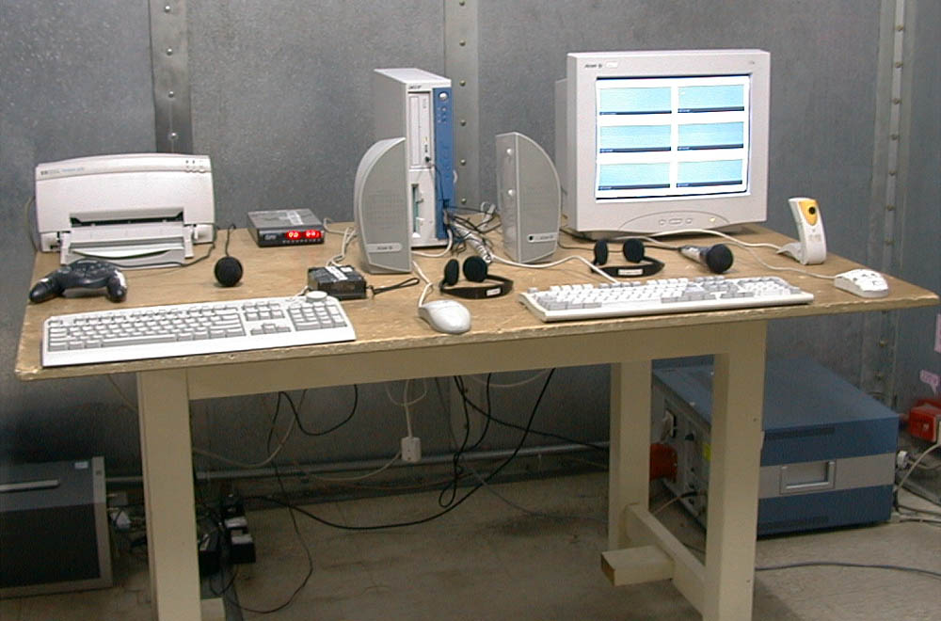
The Front View of Highest Radiated Set-up For EUT

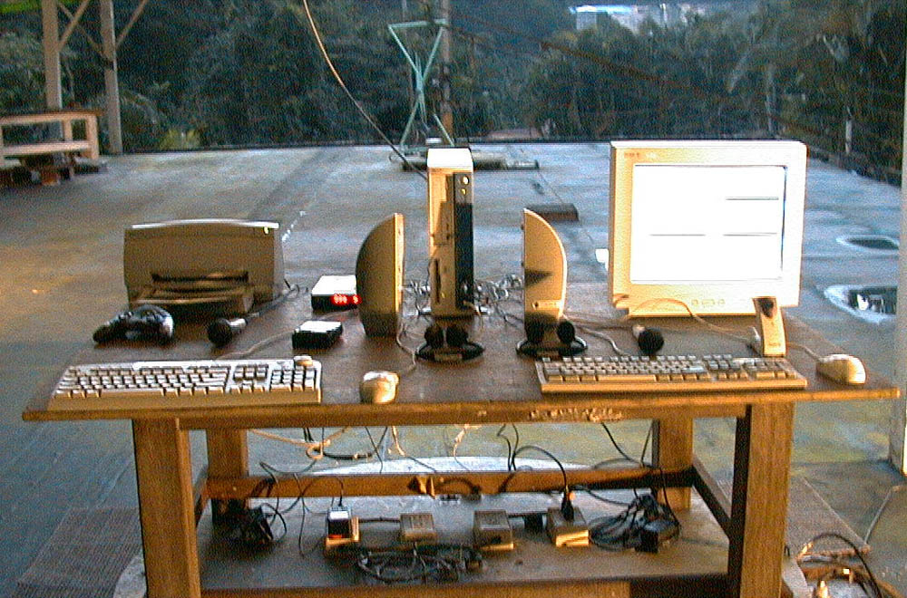

The Back View of Highest Radiated Set-up For EUT

