CE MARK TECHNICAL FILE

AUSTRALIA EMC CONSTRUCTION FILE

of

Personal Computer

Model/ Type/ Machine Type

VT3300

Contains:

1. Declaration of Conformity
2. EN55022/CISPR 22, AS/NZS 3548 Class B EMI test report
3. EN55024, AS/NZS 4252.1, EN61000-3-2, and EN61000-3-3
test report
4. Certificate of EN60950
5. Block Diagram and Schematics
6. User`s manual



Date: 2001/08/01

ISL-01A063E

Acer Incorporated
7 Hsin Ann Road
Science-Based Industrial Park
Hsinchu 300, Taiwan
R.O.C.
Telephone: (03) 577-0707
Facsimile: (03) 577-8500

Declaration of Conformity

Name of Manufacturer: Acer Inc.
Address of Manufacturer: 7 Hsin Ann Rd., Science-Based Industrial Park
Hsinchu 30077
Taiwan, R. O. C.

Declares that product: Personal Computer
Model/ Type/ Machine Type: VT3300

Assembled by: Same as above

Address: Same as above

Conforms to the EMC Directive 89/336/EEC as attested by conformity with the following harmonized standards:

EN55022:1994 /A1:1995 /A2: 1997: Limits and Methods of Measurement of Radio Interference characteristics of Information Technology Equipment

EN55024: 1998: Information technology equipment--Immunity characteristics --Limits and methods of measurement

EN61000-3-2: 1995: A1:1998/A2:1998: Limits for harmonics current emissions

EN61000-3-3: 1995: Limits for voltage fluctuations and flicker in low-voltage supply systems

Conforms to the Low Voltage Directive 73/23/EEC as attested by conformity with the following harmonized standard:

EN60950:1992 /A1:1993, A2:1993 /A3:1995 /A4:1997 /A11:1997: Safety of Information Technology Equipment Including electrical business equipment

Conforms to the C-Tick Mark requirement as attested by conformity with the following standards:

AS/NZS 3548: 1995 /A1:1997 /A2:1997: Information technology equipment
AS/NZS 4252.1:1994: Generic Immunity

2001/08/09
--------------------------- ------------------
Angus Hsieh / Sr. Director Date
Acer Inc. ISL-01A063E
EN55024 / AS/NZS 4252.1 / IMMUNITY
EN61000-3-2 / HARMONICS
EN61000-3-3 / VOLTAGE FLUCTUATIONS

TEST REPORT

of

Personal Computer

Model/ Type/ Machine Type

VT3300

Applied by:

Acer Inc.
7 Hsin Ann Rd., Science-Based Industrial Park
Hsinchu 30077
Taiwan, R. O. C.

Test Performed by:
(NVLAP Lab. Code: 200234-0)
International Standards Laboratory
No. 21, Alley 37, Lane 122, Sec. 2
Hsiwan Rd. Hsichih
Taipei Hsien 22117
Taiwan, R.O.C.

Tel:(02)2646-2550
Fax:(02)2646-4641

Contents of Report
1. General 1
1.1 Certification of Accuracy of Test Data 1
2. Summary 2
2.2 Description of Equipment Under Test 2
2.3 Description of Equipment Under Test 8
3. Electrostatic discharge (ESD) immunity 10
3.1 Electrostatic discharge (ESD) immunity test 10
4. Radio-Frequency, Electromagnetic Field immunity 11
4.1 Radio-Frequency, Electromagnetic Field immunity test 11
5. Electrical Fast transients/burst immunity 12
5.1 Electrical Fast transient/burst immunity test 12
5.2 Electrical Fast transient/burst immunity test for I/O cable 14
6. Surge Immunity 15
6.1 Surge immunity test 15
7. Immunity to Conductive Disturbance 16
7.1 Immunity to Conductive Disturbance 16
8. Power Frequency Magnetic Field immunity 17
8.1 Power Frequency Magnetic field immunity test 17
9. Voltage Dips, Short Interruption and Voltage Variation immunity 18
9.1 Voltage Dips, Short Interruption and Voltage Variation immunity test 18
10. Harmonics 19
10.1 Harmonics test 19
11. Voltage Fluctuations 22
11.1 Voltage Fluctuations test 22
12. Test Equipment List 23
12.1 Software for Controlling Spectrum/Receiver and Calculating Test Data 24
13. Photographs 25
13.1 Photos of ESD measurement 25
13.2 Photos of RF Field Strength Susceptibility Measurement 25
13.3 Photos of Electrical Fast Transient/Burst measurement 26
13.4 Photos of Surge measurement 26
13.5 Photo of Conductive Measurement 27
13.6 Photo of Magnetic field measurement 27
13.7 Photos of Voltage Dips measurement 28
13.8 Photos of Harmonics and Voltage Fluctuations 28
13.9 Appendix: Photographs of EUT 29

General

Certification of Accuracy of Test Data

The immunity tests which this report describes were conducted by an independent electromagnetic compatibility consultant, International Standards Laboratory in accordance with the EN55024:1998 / AS/NZS 4252.1:1994 which include EN61000-4 series regulations, Harmonic Current Emissions EN61000-3-2: 1995: A1:1998/A2:1998, and Voltage Fluctuations EN61000-3-3: 1995.

Equipment Tested: Personal Computer
Model/ Type/ Machine Type: VT3300
Applied by Acer Inc.
Date of test: 2001/08/01
Test Engineer: W.H. Chang

Standard | Comment | Test Results
EN61000-3-2: 1995  A1:1998/A2:1998 | Harmonic Current Emissions | Complies
EN61000-3-3: 1995 | Voltage Fluctuations | Complies
EN61000-4-2: 1995 | Electrostatic Discharge | Complies
EN61000-4-3: 1996 | Radio-Frequency, Electromagnetic Field | Complies
EN61000-4-4: 1995 | Electrical Fast Transient/Burst | Complies
EN61000-4-5: 1995 | Surge | Complies
EN61000-4-6: 1996 | Conductive Disturbance | Complies
EN61000-4-8: 1993 | Power Frequency Magnetic Field | Complies
EN61000-4-11: 1994 | Voltage Dips / Short Interruption and Voltage Variation | Complies

Approve & Signature

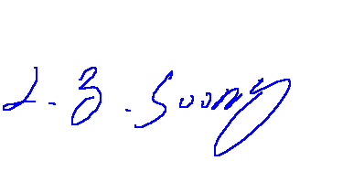

---------------------------------------------
L. Y. Soong/Director

This test report accurately contains the test results of the above standards at the time of the test.

The results in this report apply only to the sample(s) tested.

This test report shall not be reproduced except in full, without the written approval of International Standards Laboratory.

Summary

Applicant Information

Applicant: Acer Inc.
7 Hsin Ann Rd., Science-Based Industrial Park
Hsinchu 30077
Taiwan, R. O. C.

Operation Environment

Power supply : 230 Vac / 50 Hz

Description of Equipment Under Test

Description of Support Equipment

- Description: Acer Digital Camera
Model: DVC-VII
Serial Number: N/A
Power Supply Type: From PC USB Port
Power Cord: N/A
FCC ID: (Comply with FCC DOC)
- Description: Microsoft Joy Stick
Model Number: 90873
Serial Number: 01151545
Power Supply Type: N/A
Power Cord: N/A
FCC ID: C3KMGP1
- Description: Andrea Headphone
Model Number: NC-80
Serial Number: N/A
Power Supply Type: N/A
Power Cord: N/A
FCC ID: N/A
- Description: Koka Headphone
Model Number: ST-8
Serial Number: N/A
Power Supply Type: N/A
Power Cord: N/A
FCC ID: N/A
- Description: KOKA Microphone
Model Number: DM-510
Serial Number: N/A
Power Supply Type: N/A
Power Cord: N/A
FCC ID: N/A
- Description: KOKA Microphone
Model Number: DM-510
Serial Number: N/A
Power Supply Type: N/A
Power Cord: N/A
FCC ID: N/A
- Description: SONY radio cassette player
Model Number: WM-FX50
Serial Number: N/A
Power Supply Type: N/A
Power Cord: N/A
- Description: HP Printer
(for parallel interface port)
Model Number: 2225C
Serial Number: N/A
Power Supply Type: Switching
(AC to AC Xfmr, Wall Mounted Type)
Power Cord: Nonshielded, Detachable
With Grounding Pin
FCC ID: DSI6XU2225
- Description: Logitech Mouse
Model Number: M-SAH
Serial Number: LZB81251703
Power Supply Type: N/A
Power Cord: N/A
FCC ID: DZL211029
- Description: Aceex Modem
(for serial interface port 1)
Model Number: DM1414
Serial Number: 960063772
Power Supply Type: Linear, Power Adapter
( AC to AC Xfmr, Wall Mounted Type )
Power Cord: Nonshielded, Without Grounding Pin
FCC ID: IFAXDM1414
- Description: Aceex Modem
(for serial interface port 2)
Model Number: DM1414
Serial Number: 960063771
Power Supply Type: Linear, Power Adapter
( AC to AC Xfmr, Wall Mounted Type )
Power Cord: Nonshielded, Without Grounding Pin
FCC ID: IFAXDM1414
- Description: Acer Monitor
Model: 7377xe
Serial Number: 999027100501700055P644E1 P
Power Supply Type: Switching
Power Cord: Nonshielded, Detachable
FCC ID: (Comply with FCC DOC)
- Description: Acer Keyboard
Model Number: 6511-TW4C
Serial Number: 916600704C83D11076S00000
Power Supply Type: N/A
Power Cord: N/A
FCC ID: JVPKBS-WIN
- Description: Personal Computer
Model: IBM 2170
Serial No.: N/A
Power Supply Type : Switching
Delta (Model: DPS-145PB-80A)
Hard Disk Drive: Maxtor (Model: 91303D6) 13.3GB
Floppy Driver: Panasonic (Model: JU256A276P )
CD-ROM Drive: AOpen (Model: CD-940E/TKU PRO)
ZIP Driver: Iomega (Model:Z100ATAPI)
LAN Card Accton (Model: EN1207D-TX1)
FDD/HDD Controller and
VGA port/ Parallel/
Serial port: Built on Motherboard
VGA port: one 15-pin
Parallel Port: one 25-pin
Serial Port: one 9-pin
Keyboard Connector: 6-pin
Mouse Connector: 6-pin
USB Connector: two 4-pin
Game Port: one 15-pin
Speaker Port: one
Microphone Port: one
Line In Port: one
Power Cord: Nonshielded, Detachable
FCC ID: N/A (comply witch FCC DOC)
- Description: Acer USB Keyboard
Model Number: 6511-UV
Serial Number: N/A
Power Supply Type: N/A
Power Cord: N/A
FCC ID: N/A(comply with FCC DOC)
- Description: Acer USB Mouse
Model: M-U48a
Serial Number: LZE01267035
Power Supply Type: N/A
Power Cord: N/A
FCC ID: JNZ211360
- Description: Acer USB Speaker
Model Number: V-1
Serial Number: N/A
Power Supply Type: N/A
Power Cord: N/A
FCC ID: (Comply with FCC DOC)

Software for Controlling Support Unit
A test program which generates a complete line of continuously repeating "H" pattern is used as the software test program. The program was executed as follows:

- Read and write to the disk drives.
- Capture Video image from digital camera than playback to display.
- Send audio signal to the headphone.
- Send audio signal to the headphone.
- Receive audio signal from the microphone.
- Receive audio signal from the microphone.
- Receive audio signal from walkman.
- Send H pattern to the parallel port device (Printer).
- Send H pattern to the serial port device (Modem 1).
- Send H pattern to the serial port device (Modem 2).
- Send H pattern to the video port device (Monitor).
- Send signal form EUT to server through LAN port.
- Send signal form EUT to server through Telephone port.
- Repeat the above steps.

 | Filename |  |  | Issued Date
LAN | EMC.exe |  |  | 11/22/1996
Monitor | HH.bat |  |  | 8/20/1991
Modem 1 | Hm.bat |  |  | 8/20/1991
Modem 2 | Hm.bat |  |  | 8/20/1991
Printer1 | Wordpad.exe |  |  | 11/11/1999
Digital Camera | Acer Cap.exe |  |  | 8/10/1998
Telephone |  | Hypertrm.exe | 06/08/200

I/O Cable Condition of EUT and Support Units
Description | Path | Cable Length | Cable Type | Connector Type
AC Power Cord | 110V (~240V) to AC Power Cord Inlet (3-pin) | 1.8M | Nonshielded, Detachable | Plastic Head  Plastic Hood
Telephone Line | Server to EUT RJ 11 Connector | 1.2M | Nonshielded, Detachable to PC | Plastic Head  Plastic Hood
Telephone Line | with 600 Ωdummy load | 1.2M | Nonshielded, Detachable to PC | Plastic Head  Plastic Hood
Server Data Cable | Server to EUT LAN port | 33 feet | Nonshielded, Detachable | RJ-45, with Metal Head, Metal Hood
Keyboard Data Cable | Keyboard to PC Keyboard port | 1.8M | Shielded, Undetachable | Metal Head  Plastic Hood
Monitor Data Cable | Monitor to PC VGA port | 1.6M | Shielded, Detachable | Metal Head  Plastic Hood
Modem Data Cable | Modem to PC COM 1 port | 1.5M | Shielded, Detachable | Metal Head  Metal Hood
Modem Data Cable | Modem to PC COM 1 port | 1.5M | Shielded, Detachable | Metal Head  Metal Hood
Mouse Data Cable | Mouse to PC Mouse port | 1.8M | Shielded, Undetachable | Metal Head  without Hood
Printer Data Cable | Printer to PC Parallel port | 1.5M | Shielded, Detachable | Metal Head  Plastic Hood
Audio-in Data Cable | Walkman to PC Audio-In Port | 1.5M | Nonshielded, Detachable to PC | Metal Head  Plastic Hood
Microphone Data Cable | Microphone to Mic Jack of PC | 1.5M | Nonshielded, Undetachable | Metal Head  Plastic Hood
Microphone Data Cable | Microphone to Mic Jack of PC | 1.5M | Nonshielded, Undetachable | Metal Head  Plastic Hood
Headphone Data Cable | Headphone to Line-out jack of PC | 1.5M | Nonshielded, Undetachable | Metal Head  without Hood
Headphone Data Cable | Headphone to Line-out jack of PC | 1.5M | Nonshielded, Undetachable | Metal Head  without Hood
Joy Stick Data Cable | Joystick to PC Joystick port | 1.2M | Shielded, Undetachable | Metal Head  without Hood
USB CCD Data Cable | Digital camera to PC USB port | 1.6M | Shielded, Detachable | Metal Head  Plastic Hood

Description of Equipment Under Test

EUT

Description: Personal Computer
Condition: Pre-Production
Model: VT3300
Serial Number: N/A
Power Supply Type: Switching
FSP(Model:FSP160-60SAV(PF)) 160W
Hard Disk Driver: Seagate (Model: ST340810A) 40GB
Floppy Driver: Panasomic(Model:JU-256A046P)
DVD-ROM Driver: Pioneer (Model: DVD-116)
VGA Card: LEADTEK(Model: Winfast Geforce 2 MX)
Modem Card: ASKEY (Model: 1456VQH20E)
FDD/HDD Controller and
Parallel/Serial ports: Built on Motherboard
Parallel Port: one 25-pin
Serial Port: two 9-pin
LAN Port: one 8-pin
Keyboard Connector: one 6-pin
Mouse Connector: one 6-pin
USB Connector: four 4-pin
Game Port: one 15-pin
Speaker Port: two
Microphone Port: two
Line In Port: one
Power Cord: Nonshielded, Detachable
Display: CRT
Maximum Resolution: 1280X1024

Speed and CPU
100MHz Pentium 4-1.4,1.5,1.7,1.8,1.9,2.0GHz

All types of CPU, switching power supplies, hard disk drivers, cd-rom drivers, modem cards, and video modes listed above have been tested, we only present the worst case test data in the report. The test configuration is listed below:
CPU: Pentium 4-2.0 GHz
Power supply: FSP(Model:FSP160-60SAV(PF)) 160W
Hard disk driver: Seagate (Model: ST340810A) 40GB
VGA Card: LEADTEK(Model: Winfast Geforce 2 MX)

EMI Noise Source:
Crystal: 25MHz (X1), 14.318MHz (X2),32.768KHz (X3),24.576MHz(X4)
Clock Generator:U8
EMI Solution:
- Five spring fingers were added between add-on card bracket and metal enclosure

Electrostatic discharge (ESD) immunity

Electrostatic discharge (ESD) immunity test

Port: Enclosure
Basic Standard: EN61000-4-2
Requirements: Air +/- 8 kV
Contact +/- 4 kV
Criteria: B
Temperature: 25 degree C
Humidity: 59%

Test Setup

EUT is 1m from the wall and other metallic structure.

10cm

0.5m x 0.5m metal plane

EUT

0.5mm insulation
1.6m x 0.8m metal plane

Non-Metallic /
Non-Conducted Table

470KΩ 80 cm
470KΩ

Metal Full Soldered Ground Plane

Test Result

Performance of EUT complies with the given specification.

Radio-Frequency, Electromagnetic Field immunity

Radio-Frequency, Electromagnetic Field immunity test
Port: Enclosure
Basic Standard: EN61000-4-3
Modulation AM 1KHz 80%
Requirements: 3 V/m
Frequency range: 80 MHz~1 GHz
Step: 1% of last step frequency
Step time: 800 ms
Polarization: Vertical and Horizontal
Criteria: A
Temperature: 26 degree C
Humidity: 46%

Test Setup

The field sensor is placed at one calibration grid point to check the intensity of the established fields on both polarizations. EUT is adjust to have each side of EUT face coincident with the calibration plane. A CCD camera is used to monitor the condition of EUT for the performance judgment.

1 m
Anechoic Chamber

EUT

Non-Conducted
Table
To Amplifier output

80 cm 1.55m

To Remote Controller

Metal Full Soldered Ground Plane
Amplifier
Signal Generator
To Antenna

Test Result

Performance of EUT complies with the given specification.

Electrical Fast transients/burst immunity

Electrical Fast transient/burst immunity test

Port: AC mains
Basic Standard: EN61000-4-4
Requirements: 1 KV
Criteria: B
Rise Time: 5ns
Hold Time: 50ns
Repetition Frequency: 5KHz
Temperature: 25 degree C
Humidity: 59%

Test Procedure

The EUT was setup on a nonconductive table 0.8 m above a reference ground plane.

 | Voltage | 1 KV
Test Points | Polarity | Result | Comment
Line | + | N | 60 sec
 | - | N | 60 sec
Neutral | + | N | 60 sec
 | - | N | 60 sec
Ground | + | N | 60 sec
 | - | N | 60 sec
Line to | + | N | 60 sec
Neutral | - | N | 60 sec
Line to | + | N | 60 sec
Ground | - | N | 60 sec
Neutral to | + | N | 60 sec
Ground | - | N | 60 sec
Line to Neutral | + | N | 60 sec
to Ground | - | N | 60 sec
Note: ’N’ means normal, the EUT function is correct during the test.

Test Setup

EUT is at least 50cm from the conductive structure .

EUT
AC main

10cm insulation support

Non-Metallic /
Capacitive coupling Non-Conducted Table
test generator

80 cm clamp
AE

10cm
Metal Full Soldered Ground Plane insulation support

Test Result

Performance of EUT complies with the given specification.

Electrical Fast transient/burst immunity test for I/O cable

Port: phone, twisted pairs LAN port
Basic Standard: EN61000-4-4
Requirements: 0.5 kV
Criteria: B
Rise Time: 5ns
Hold Time: 50ns
Repetition Frequency: 5KHz
Temperature: 25 degree C
Humidity: 59%

Test Result

Performance of EUT complies with the given specification.

Surge Immunity

Surge immunity test

Port: AC mains and Telephone Line
Basic Standard: EN61000-4-5
Criteria: B
Rise Time: 1.2us
Hold Time: 50us
Temperature: 25 degree C
Humidity: 59%
Test Level: AC Power Port: 1 kV (line to line), 2kV (line to earth)
Telephone Line: 1kV (line to ground)

Repetition Rate: ☑ 30 second
Angle: ☑ 0°
☑ 90°
☑ 270°
Polarity: ☑ positive ☑ negative°

Test Setup

AC power supply and
Voltage Supply to EUT

EUT
To the Peripherals

To AC main Supply Non-Metallic /
Non-Conducted Table

80 cm

Transient-1000

Metal Full Soldered Ground Plane

Test Result

Performance of EUT complies with the given specification.

Immunity to Conductive Disturbance

Immunity to Conductive Disturbance

Port: AC mains & Telephone ports & LAN port
Basic Standard: EN61000-4-6
Test Level: 3 V
Modulation AM 1KHz 80%
Criteria: A

Frequency range: 0.15 MHz - 80MHz
Step: 1% of last Frequency
Step time: 1000 mS
Temperature: 25 degree C
Humidity: 59%

Test Setup

30mm 50Ω
Amplifier

EUT
with earth terminal
CDN

30~50mm
To AC main To AC main
CDN
AE
Supply Supply
Signal
Generator
0.1 m support

Metallic
Plane
Non-Metallic / 1m x 1m
Non-Conducted Table metal
ground
80 cm plane

This Metal Plane is 50cm
from the wall

Metal Full Soldered Ground Plane

Test Result

Performance of EUT complies with the given specification.

Power Frequency Magnetic Field immunity

Power Frequency Magnetic field immunity test

Port: Enclosure
Basic Standard: EN61000-4-8
Requirements: 1 A/m
Criteria: A
Orientation: X, Y, Z
Temperature: 25 degree C
Humidity: 59%

Test Setup

3m
Magnetic Field Antenna (1m x 1m)

To AC To the
EUT
Power Peripheral metal ground
To AC main Source plane
Supply

Non-Metallic /
Non-Conducted Table

80 cm insulation support

Transient 1000

Ground
Wire

Metal Full Soldered Ground Plane
Test Result

Performance of EUT complies with the given specification.

Voltage Dips, Short Interruption and Voltage Variation immunity

Voltage Dips, Short Interruption and Voltage Variation immunity test

Port: AC mains
Basic Standard: EN61000-4-11
Phase: 0°
Test intervals: 3 times with 10s each

Voltage Dips: >95% in 0.5 period
Criteria: B

Voltage Dips: 30% in 25 period
Criteria: C

Voltage Interruption: >95% in 250 period
Criteria: C

Test Setup

AC power supply to EUT
Interruptions & Voltage
Dips Control
To AC main To the Peripherals

EUT
Supply

Non-Metallic /
Non-Conducted Table

Transient-1000

80 cm

Metal Full Soldered Ground Plane

Test Result

Performance of EUT complies with the given specification.

Harmonics

Harmonics test

Port: AC mains
Active Input Power: >75W
Basic Standard: EN61000-3-2
Test Duration: 3min.
Class: D

Test Procedure

The EUT is supplied in series with shunts or current transformers from a source having the same nominal voltage and frequency as the rated supply voltage and frequency of the EUT. The EUT is configured to its rated current with additional resistive load when the testing is performed.
Equipment having more than one rated voltage shall be tested at the rated voltage producing the highest harmonics as compared with the limits.

Result

Performance of EUT complies with the given specification.
Test Data

Power (W) | Power Factor | Power Voltage | Power Current
156.474 | 0.773 | 229.398 | 0.733

Maximum permissible harmonic current (A)
Order | Data | Order | Data | Order | Data
1 |  | 16 | 0.0003 | 31 | 0.0031
2 | 0.0019 | 17 | 0.0079 | 32 | 0.0003
3 | 0.4618 | 18 | 0.0003 | 33 | 0.0023
4 | 0.0008 | 19 | 0.0070 | 34 | 0.0005
5 | 0.1591 | 20 | 0.0003 | 35 | 0.0025
6 | 0.0004 | 21 | 0.0048 | 36 | 0.0005
7 | 0.0555 | 22 | 0.0003 | 37 | 0.0021
8 | 0.0003 | 23 | 0.0048 | 38 | 0.0002
9 | 0.0252 | 24 | 0.0003 | 39 | 0.0017
10 | 0.0004 | 25 | 0.0037 | 40 | 0.0002
11 | 0.0218 | 26 | 0.0003 | 41
12 | 0.0003 | 27 | 0.0036 | 42
13 | 0.0134 | 28 | 0.0003 | 43
14 | 0.0003 | 29 | 0.0030 | 44
15 | 0.0132 | 30 | 0.0003 | 45

Test Data

Power (W) | Power Factor | Power Voltage | Power Current
156.474 | 0.773 | 229.398 | 0.733

Maximum permissible harmonic current per watt (mA/W)
Order | Data | Order | Data | Order | Data
3 | 2.9595 | 17 | 0.0506 | 31 | 0.0197
5 | 1.0213 | 19 | 0.0448 | 33 | 0.0146
7 | 0.3556 | 21 | 0.0306 | 35 | 0.0158
9 | 0.1617 | 23 | 0.0306 | 37 | 0.0132
11 | 0.1399 | 25 | 0.0234 | 39 | 0.0108
13 | 0.0861 | 27 | 0.0232
15 | 0.0845 | 29 | 0.0195

Voltage Fluctuations

Voltage Fluctuations test

Port: AC mains
Basic Standard: EN61000-3-3
Observation period: For Pst 10min
For Plt 2 hours

Test Procedure

The EUT is supplied in series with reference impedance from a power source with the voltage and frequency as the nominal supply voltage and frequency of the EUT.

Result

Performance of EUT complies with the given specification.

Test Equipment List

Location Remark | Equipment | Brand | Model | Start  Service Date | Last  Cal. Date | Next  Cal. Date
2,4,5,8,11 | Test Generator | PRECISION | TRA1000-126  S/N: TRA1H01B | 6/30/1994 | 8/9/2000 |  | 8/9/2001
3,6 | Power meter | HP | 438A  S/N: 3513U06187 | 10/23/1997 | 10/23/2000 |  | 10/23/2001
3,6 | Power Sensor | HP | 8482A  S/N: 3318A29614 | 10/23/1997 | 1/03/2000 |  | 1/03/2001
3 | Signal Generator | HP | 8648B  S/N: 3642U01040 | 6/30/1997 | 3/13/2001 |  | 3/13/2003
3 | BILOG Antenna | CHASE | CBL6112  S/N: 2077 | 10/20/1998 | 1/10/2001 |  | 1/09/2002
3 | Power Amplifier | Amplifier Research | 100W1000M1  S/N: | 3/31/1996 | N/A |  | N/A
3 | Field Strength Sensor | Amplifier Research | FP2000  S/N: 15397 | 3/31/1996 | N/A |  | N/A
3 | Field Strength Meter | Amplifier Research | FM2000  S/N: A285000011 | 3/31/1996 | N/A |  | N/A
3 | Thermo-hygrometer | CRECER | S/N: ISL-C-003 | 11/26/1999 | 1/12/2001 |  | 1/11/2002
4 | Clamp | Precision | 1604242  S/N: CNEFT1000-103 | 6/30/1994 | N/A |  | N/A
5,6 | CDN | FCC Inc. | FCC-801-T2  S/N:9720 | 6/30/1994 | 1/11/2001 |  | 1/10/2002
6 | CDN | FCC Inc. | FCC-801-T4  S/N: 9721 | 6/30/1994 | 1/11/2001 |  | 1/10/2002
6 | CDN | FCC Inc. | FCC-801-M3-25A  S/N: 2032 | 6/30/1994 | 1/11/2001 |  | 1/10/2002
6 | Signal Generator | HP | 8656B  S/N: 2635A04675 | 6/30/1992 | 8/17/2000 |  | 8/17/2001
6 | Power Amplifier | Amplifier Research | 150A100  S/N: 1-1-R-02157 | 3/1/1996 | N/A |  | N/A
6 | Passive Impedance Adapter | FCC Inc. | FCC-801-150-50-CDN  S/N: 9758 & 9759 | 3/1/1996 | N/A |  | N/A
6 | 50 ohms load | Weinschel Corp | 1429-4  S/N: DB3318 | 3/1/1996 | N/A |  | N/A
6 | 6dB Attenuator | Weinschel Corp | 33-6-34  S/N: BC5975 | 3/1/1996 | N/A |  | N/A
8 | Magnetic Field Antenna | Precision | TRAIZ44B  S/N: MF1000-23 | 8/30/1997 | N/A |  | N/A
8 | Clamp Meter | TES | 3090  S/N: 990900322 | 5/09/2001 | 5/09/2001 |  | 5/09/2002
*2, *3 | 3-Channel Power Analysis System | Xitron Technologies | 2503AH  S/N: 25015940001 | 6/30/1994 | 2/09/2001 |  | 2/09/2002
*2, *3 | Frequency Converter | Extech Electronics | CFC-110 | 6/30/1994 | N/A |  | N/A
2,4,5,6,8,11 | Thermo-hygrometer | MICROLIFE | S/N: ISL-C-004 | 11/26/1999 | 1/12/2001 |  | 1/12/2002
Note: ***: The equipment is sent for calibration.

Location Remark List:
2: EN61000-4-2 3: EN61000-4-3 4: EN61000-4-4 5: EN61000-4-5
6: EN61000-4-6 8: EN61000-4-8 11: EN61000-4-11
*2: EN61000-3-2 *3:EN61000-3-3

Software for Controlling Spectrum/Receiver and Calculating Test Data
Radiation/Conduction |  | Filename | Version
EN61000-3-2 | IEC1000.EXE |  | 1.0F
EN61000-3-3 | IEC1000.EXE |  | 1.0F
EN61000-4-3 | Tile.Exe |  | 1.12.E
EN61000-4-6 | Tile.Exe |  | 1.11.J
EN61000-4-2 | Tracs.Exe |  | 2.0
EN61000-4-4 | Tracs.Exe |  | 2.0
EN61000-4-5 | Tracs.Exe |  | 2.0
EN61000-4-8 | Tracs.Exe |  | 2.0
EN61000-4-11 | Tracs.Exe |  | 2.0

Photographs

Photos of ESD measurement

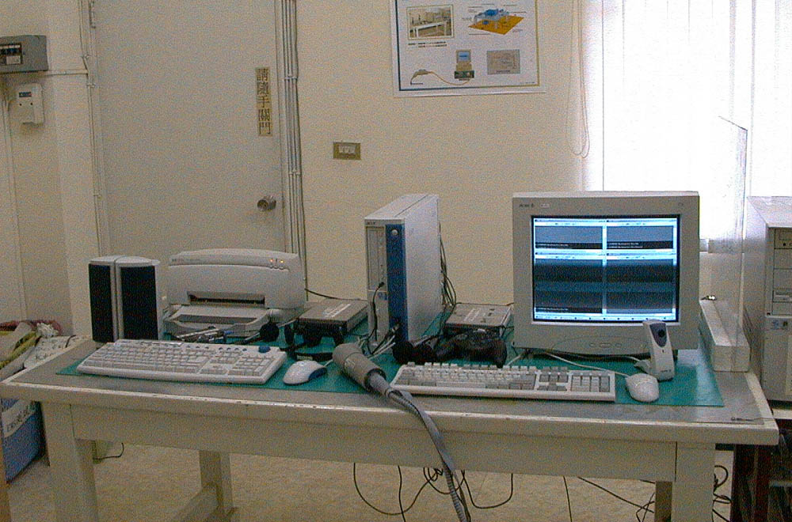

Photos of RF Field Strength Susceptibility Measurement
.

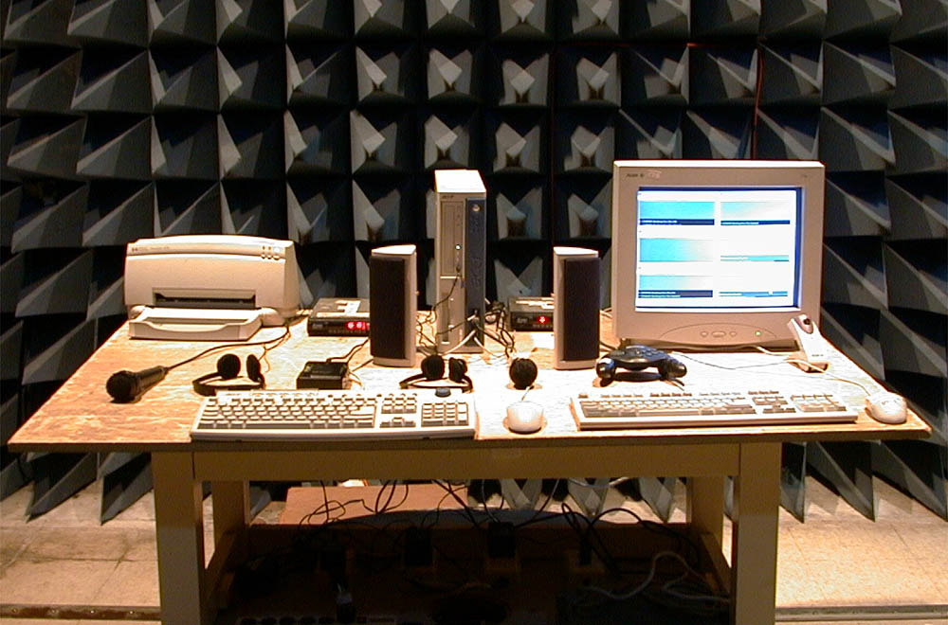Photos of Electrical Fast Transient/Burst measurement

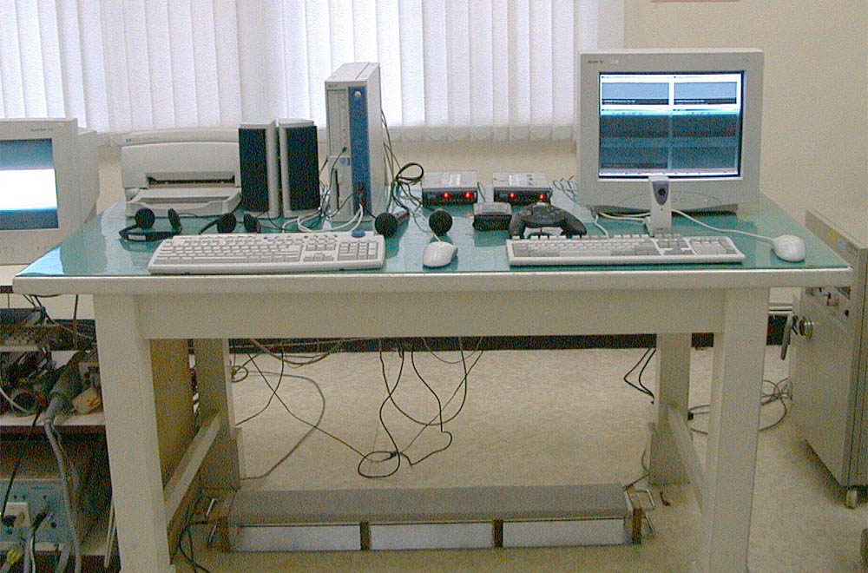

Photos of Surge measurement

Photo of Conductive Measurement

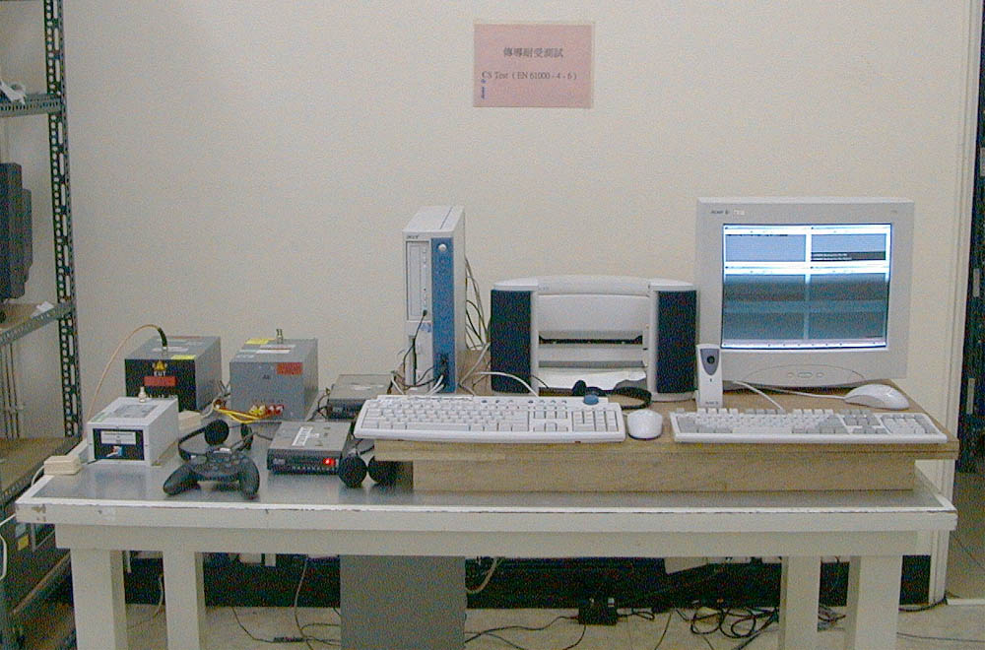

Photo of Magnetic field measurement

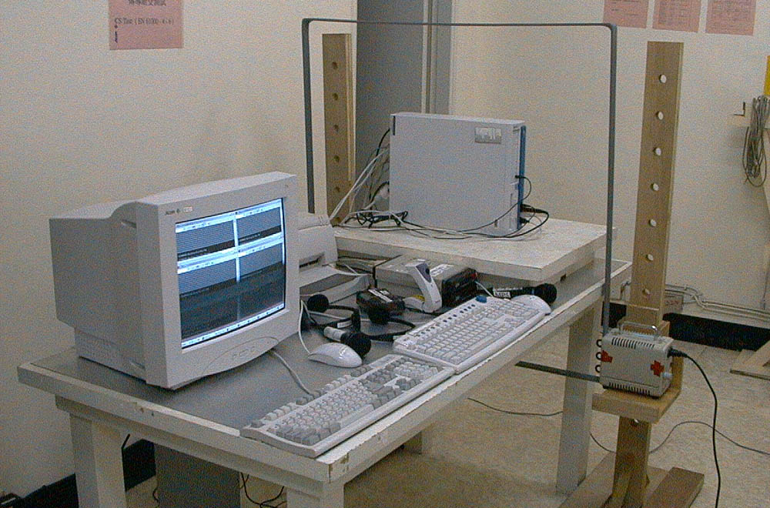

Photos of Voltage Dips measurement

Photos of Harmonics and Voltage Fluctuations

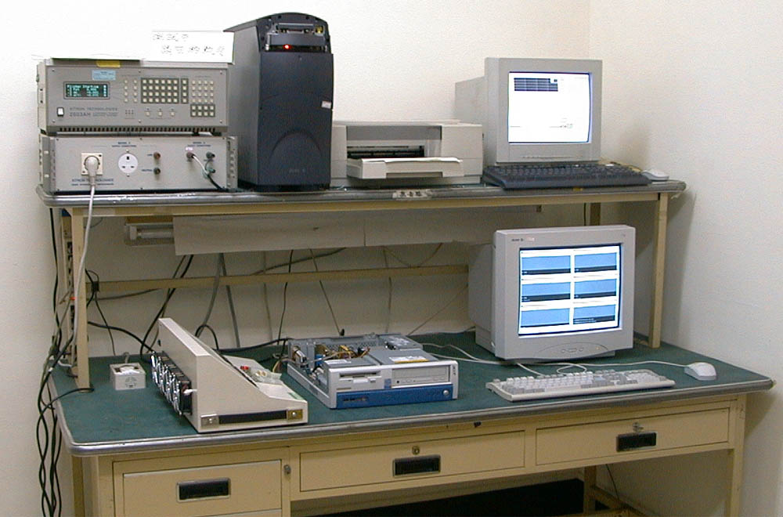

Appendix: Photographs of EUT

Please find this appendix in the File of ISL-01A063P

