- Update System BIOS(1 M)﹕
1. 1 DOS Mode:
1.1.1 Boot to DOS , then go to DosTools and execute "flash1M.bat" in1MB BIOS package to refresh System BIOS.
1.1.2 Reboot system and Press "del" to enter BIOS setup menu.
1.1,3 Load default setting, and Save & Exit.

.1.2 WindowsXP/Vista
1.2.1 Right click “AFUWIN.exe” and Select “Run as administrator” and then select “Allow I trust this program, I know wherer I’ts from or I’ve used it before”
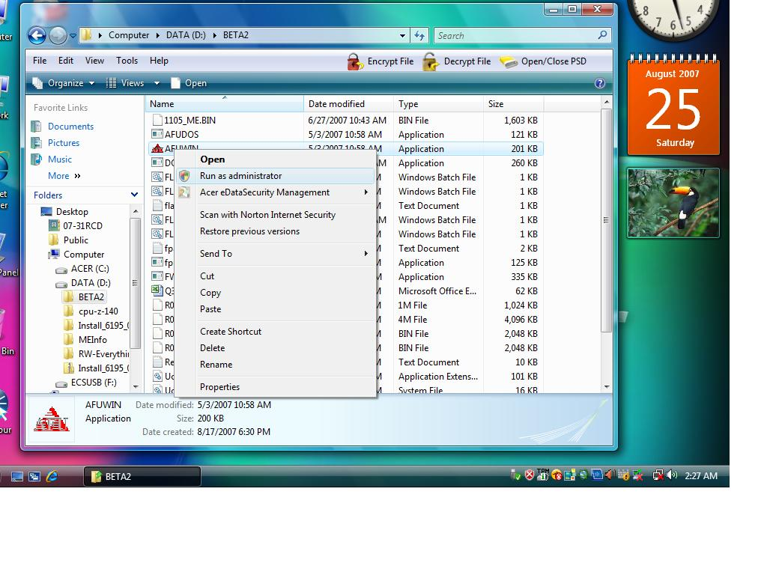
1.2.1 Select “OK”
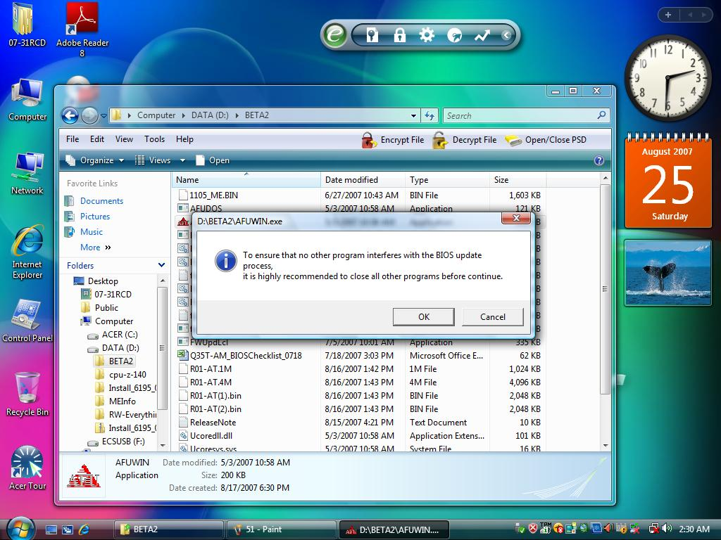
1.2.2 Click “open” button
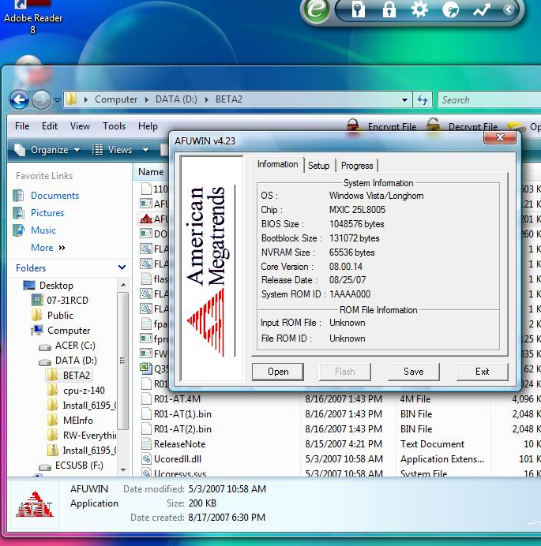
1.2.3 Select 1M BIOS ( ROM\R01-A2.1M)
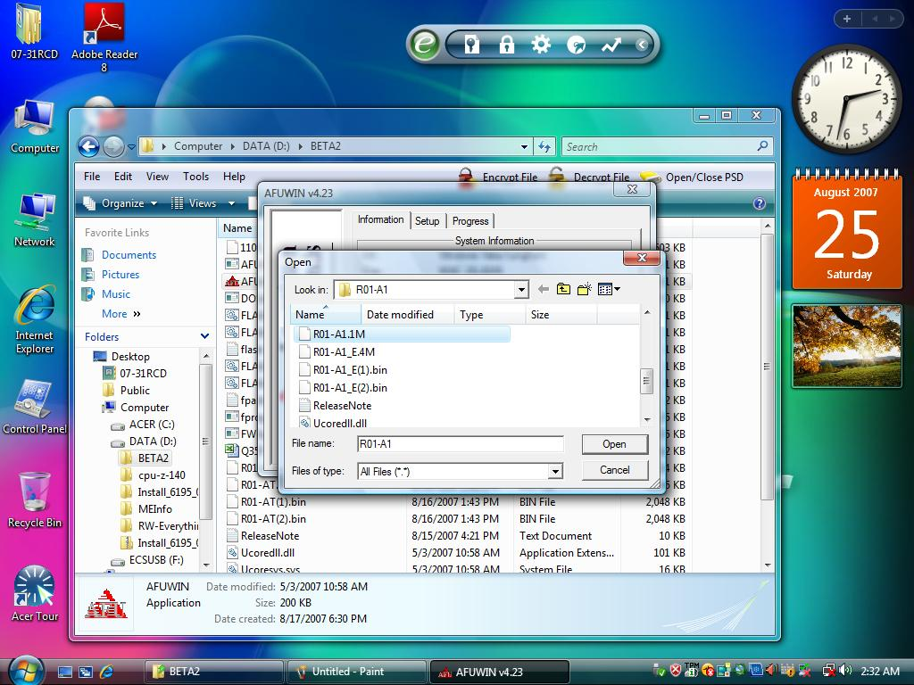
1.2.4 Check “program All Block”, click “Preserve SMBIOS” and then Press ‘A’ to protect DMI Data , check “Destroy CMOS Checksum” and “Restart After Programming”
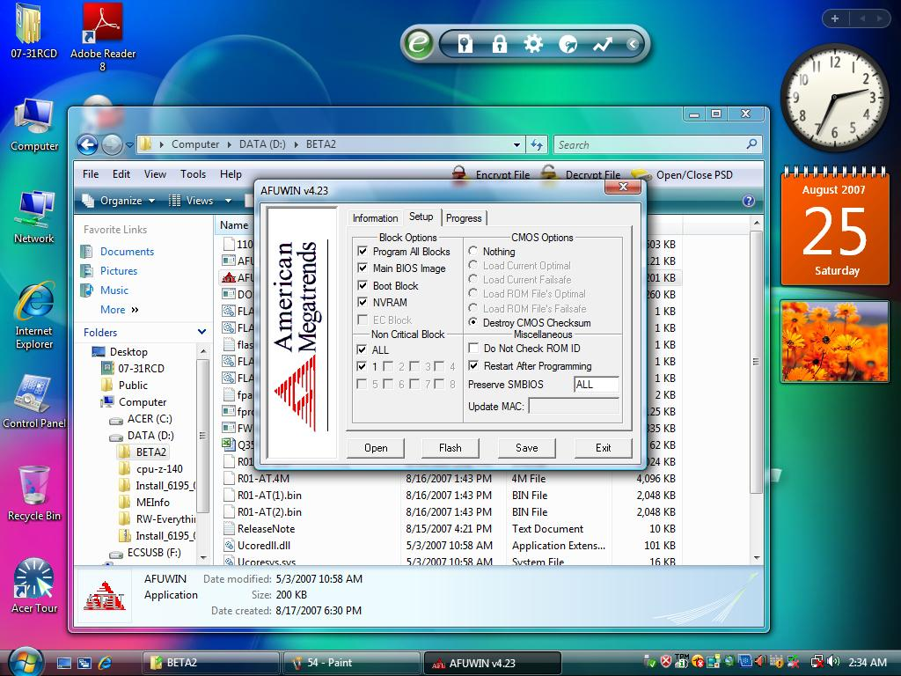
1.2.5 Click “Flash” button
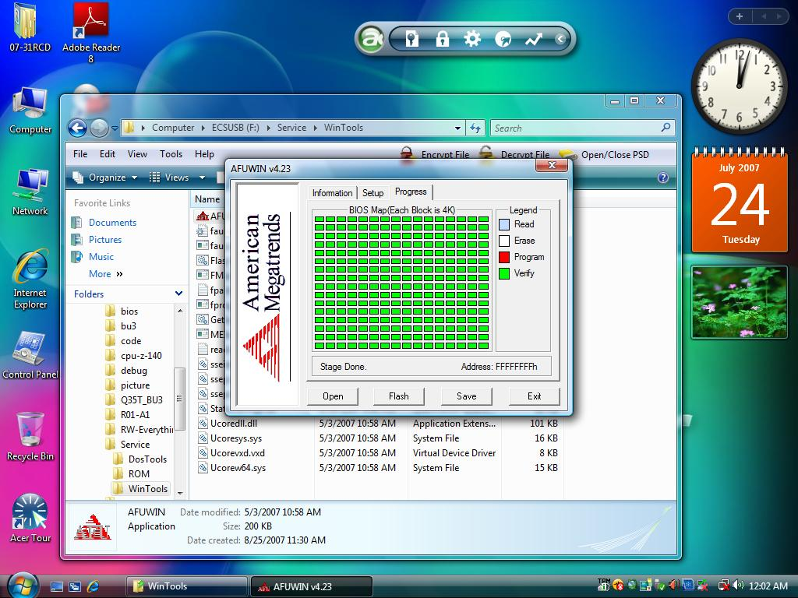
1.2.6 Re-Start system

