Device Driver "FastVoodoo2 4.0 XP Gold Edition” Release Notes
http://www.3dfxzone.it/

These Release Notes provide information on the following topics:
- What's new?
- Compatibility and hardware/software configuration request
- Voodoo2 hardware small description
- Hardware Installation
- Driver Setup
- OverClock Tab Setup
- Control Panel
- Control Panel Settings and Configuration
- Set Up refresh frequency
- AntiAliasing
- Troubleshoting
- Support, Help, Tutorial and Tweak at 3dfxzone.it forums
- Greetings
- Dedications
[What's new?]
>> Improvements
- Improved compatibility with GLide games
- Improved compatibility with OpenGL games: this release supports Quake3 Arena based
games with both Voodoo driver and default driver
- 3dfx, Creative and Wicked3D miniGL included in this package: you can use
Creative library to get 1024x768 or above resolutions (in some games) with one Voodoo2
- Two 3dfx GLide technology demos included in this package
- Improved compatibility with AMD processors based machines
>> Fixed Issues
- Fixed issue with Enhance my desktop setting in Advanced Properties of driver
control panel
- Fixed issue with WickedGL control panel: now you can set up mipmap dithering
and triple buffering without application error
- Fixed (or in some cases reduced) issue with hardware and software configurations that
use a GeforceFX or Radeon 9500/9600/9700/9800 as primary card
- Fixed issue with systems that use a GeforceFX 5600 as primary card: now you play games
with Voodoo2 without Mapmem returned an error trying to map memory error
- Fixed issue with PowerVR Kyro II equipped systems: now you don't get errors after
Operative System boots and besides FastVoodoo2 control panel runs fine
>> Known Issues
- Hiting System Info button in driver contro panel you get a bad view: we will work to fix this in newer releases
[Compatibility and hardware/software configuration request]
- 3dfx Voodoo2 or 3dfx Voodoo2 SLI based card(s)
- Intel or AMD cpu running Windows 2000/XP Operative Systems
- OpenGL and GLide applications.
- MS DirectX 9.0 or above
[Voodoo2 hardware small description]
>> PCB
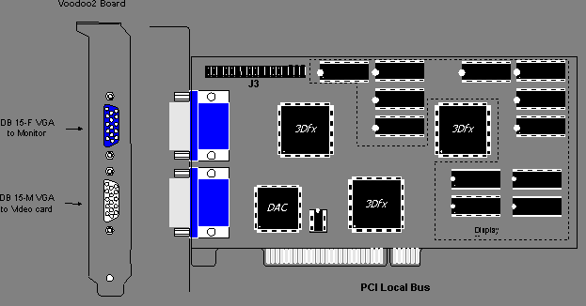
>> Voodoo2 Frequency Table
Resolution | Vertical Rate | Pixel Clock | Dot Clock | Multiplier
640x480 | 60 Hz | 50.35 Mhz | 25.175 Mhz | X2
640x480 | 75 Hz | 63.0 Mhz | 31.5 Mhz | X2
640x480 | 85 Hz | 72.0 Mhz | 36.0 Mhz | X2
640x480 | 120 Hz | 101.64 Mhz | 50.82 Mhz | X2
800x600 | 60 Hz | 80.0 Mhz | 40.0 Mhz | X2
800x600 | 75 Hz | 99.0 Mhz | 49.5 Mhz | X2
800x600 | 85 Hz | 112.5 Mhz | 56.25 Mhz | X2
800x600 | 120 Hz | 83.95 Mhz | 83.95 Mhz | X1
1024x768 | 60 Hz | 65.0 Mhz | 65.0 Mhz | X1
1024x768 | 75 Hz | 78.75 Mhz | 78.75 Mhz | X1
1024x768 | 85 Hz | 94.5 Mhz | 94.5 Mhz | X1
The pixel clock can run at either x1 or x2 of the dot clock depending on the resolution and refresh rate. The table above lists the pixel clock frequency based on the mode that is being set at initialization.
>> Definition
Pixel Clock = The digital interface clock between the TMU and the DAC.
Dot Clock = The DAC output clock that defines the frequency of the RGB signals going to the VGA monitor.
[Hardware Installation]
To avoid accidental electric shock, be sure to shut your computer down and unplug the power cord before starting the following procedures. To protect your Voodoo2 card from damage due to static electrical discharge, ground yourself by touching the power supply box inside your computer.
With the power off, remove your computer cover. Find an available PCI slot and remove the bracket and screw. Remember which cables go to which connectors. You may want to label your computer's cables before disconnecting them.
Insert Voodoo2 firmly into a PCI slot. Care should be taken to press it evenly and snugly into its slot. Once you are certain Voodoo2 is installed properly in its slot, secure it with a screw.

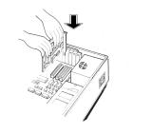 | 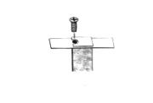
Connect the lower port on Voodoo2 to the monitor port on your existing graphics board with the provided VGA pass-through cable:
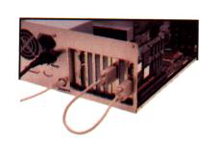
Connect the upper port on Voodoo2 to your monitor with a standard monitor cable.
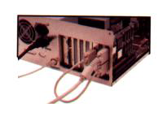
Secure your computer cover and reattach any cables.
If you are installing two Voodoo2 cards to get the configuration, continue with the instructions immediately below. Otherwise, you are ready to install Voodoo2 software. See the Driver Setup section below.
>> Installing two cards for SLI connection
For the 2 cards upgrade you need 2 identical Voodoo2 cards connected with the internal data cable. Install both Voodoo2 cards into adjacent PCI slots in your .
Use the data cable to connect the connectors J3 on both Voodoo2 cards. The connectors on the cable and on the cards are keyed to ensure correct connections. Connect one of the Voodoo2 cards to your graphics card and to your .
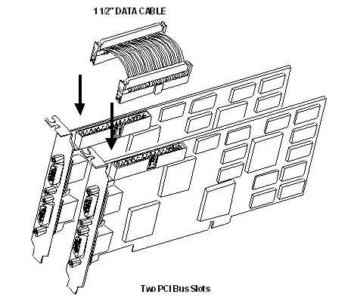
Once you have completed installing all of the Voodoo2 hardware, reconnect your computer cover and power cord. Now you have to install Voodoo2 driver so continue with the instructions below.
[Driver Setup]
>> Automatic Install
0) Install MS DirectX 9.0 or above and reboot the system.
1) Click on downloaded file named "fv2_4.0_xp_ge" and unzip the FastVoodoo2 4.0 XP Gold Edition folder.
2) Remove any previus Voodoo2 Windows 2000/XP driver (for example FastVoodoo2 3.0 XP) from Windows control panel.
3) Reboot the system.
4) If Windows now detects Voodoo2 card and searchs for a driver you must stop any request and hit on “Cancel button”.
5) Double click on Setup.exe file located in FastVoodoo2 4.0 XP Gold Edition folder
6) Follow the on screen istructions
7) Reboot the system
8) Voodoo2 SLI users must do twice the step 4 before to go to step 5
[OverClock Tab Setup]
1) Open the FastVoodoo2 4.0 XP Gold Edition/Tools/Tweaker folder
2) Copy Voodoo2_OC directory in Windows/System32 dir (for Windows XP users) or Winnt/System32 dir (for Windows 2000 users)
3) Double click on “V2_OC_control_panel.exe” file
4) Reboot the system
[Control Panel]
You can make custom adjustments to your monitor’s display settings using the driver control panel.
To open the control panel:
- Double-click on My Computer. When the window opens, scroll or browse until you see the Control Panel folder
- Double-click on Control Panel. When this window opens, scroll or browse until you see the Display control panel
- Double-click on Display. The Display Properties sheet appears
- Click on the Settings tab, then on Advanced
Now 3dfx Voodoo2 and Voodoo2 OC tabs are displayed
[Control Panel Settings and Configuration]
When 3dfx Voodoo2 and Voodoo2 OC tabs are displayed are visible, you will see several slider controls and buttons
>>> 3dfx Voodoo2tab - Main
- Refresh Rates
This control allows you to adjust the refresh rates used by many games running on 3dfx Voodoo2. At the moment we are not able to activate this control so you must do manually running registry files in \Tools\Refresh_rate directory. You will not need to restart your computer for the changes to take effect
- Gamma Correction
Use Gamma Correction to change the brightness levels used by 3D games. Some games may appear too dark or too bright. Each of the gamma sliders controls brightness levels for red, green, and blue as they appear in games running on 3dfx Voodoo2. Manually adjust each of the sliders, apply, and test with your game until you achieve the brightness you want. Moving sliders to the left decreases brightness; to the right increases brightness
- Link Gamma Sliders
Select this checkbox to chain all three of the sliders together so that adjusting one slider adjusts them all.
>> 3dfx Voodoo2 - Advanced Properties
This dialog offers advanced checkbox settings for Voodoo2 Glide. The available options for Direct3D or Glide are located in their respective box. The individual checkboxes are described in greater detail below. These settings are for experienced users. Selecting these options may cause problems with some games and hardware configurations.
>> Glide Advanced Properties
- Don’t Sync Buffer Swaps to Monitor Refresh Rate for Glide apps
When selected, Glide applications will not synchronize buffer swaps with the vertical retrace signal of the monitor. Rendering performance may increase when this option is selected; however, visual tearing may occur.
- Force mipmap dithering for Glide apps
This option will guarantee that the mip map blending will use the hardware dithering option which can smooth the transition between mip levels. This can increase the visual quality in some games. Mip levels are pre scaled texture maps that are appropriate for polygons of various distances away from the viewer. Sometimes there is are visible texture transitions in a polygon jutting out whose surface transitions though several mip levels. The dithering can soften this effect. But at a slight performance hit.
- Limit Texture Memory to 2mb for Glide apps
When selected, Glide applications will limit the use of texture memory to 2 MBytes for each texture mapping unit. Some (old) Glide games may not work correctly if this option is not selected
- Force triple color buffering for Glide apps
Triple buffering has the same advantage as double buffering (no screen tearing - looks smooth) with the additional advantage of increased efficiency (i.e. higher frame rate) in some cases. One way to describe the advantage is that the CPU and 3D card are not as tightly linked with triple buffering which can lead to some performance gains due to work done in parallel. Triple buffering takes more memory in the video card frame buffer. This does not affect texture memory. Not all games support this setting.
- Disable Scanline Interleaving (SLI)
When selected, Glide will not auto-detect SLI boards: it can help some games run properly.
- Enhance my desktop
When selected, you will enhance you Windows desktop with a background logo image from 3dfxzone.it, expressing your devotion to technology and high end 3D graphics by 3dfx and 3dfxzone.it.
>> Voodoo2 OC tab
- Overclock slider control
Using this slider one you change hardware clock: tipical value for Voodoo2 chipset is 90mhz. Please note that overclock is potentially dangerous for your card: of course, you must abundantly cooling the card before increasing clock.
[AntiAliasing]
3dfx Voodoo2 chip-set has ability of rendering with AntiAliasing that makes the edges smoother (less jaggies) and gives a higher image quality. Voodoo2 can only do Edge AntiAliasing: this means that aliasing-effects, that are not situated at the border of a polygon, are left untouched. Since Voodoo2 stores its rendered pixels immediately in external Ram while the antialiasing is done when the whole image is already rendered, the hardware has to read several pixels out of the external memory, to use some sort of filtering on them and store them again in external ram. So AA involves read, modify and write operations. Because accessing to external memory reduces memory bandwidth and steals it to the other rendering actions a drop in the number of fps occurs. Remember that less fill rate is less fps.
>> You can enable experimental AntiAliasing support with a double click on the files "glide_aa_on".
>> You can disable experimental AntiAliasing support with a double click on the files "glide_aa_off".
All these files are located in \Tools\AntiAliasing directory of FastVoodoo2 3.5 XP package.
[Set Up refresh frequency]
Default refresh frequency for all supported screen resolutions is 60Hz. You can change this valute to 75Hz or 85Hz by the reg files included in \Tools\Refresh_rate directory of FastVoodoo2 4.0 XP Gold Edition package.
[Troubleshoting]
- Enabling antialiasing you can get a great fps loss because the graphic processors must execute other calculations due to algorithms for the rendering with edge antialiasing too. So please reduce the screen resolution for more balanced performance.
- Voodoo2 SLI users: default FV2 4.0 XP driver layout includes V-Sync off so that flips occur as soon as possible (often at the next horizontal retrace signal). This eliminates the potentially long wait for the vertical retrace signal, but may introduce some tearing of the display image. The tearing occurs when portions of two or more frames (which represent the scene at different simulated times or viewpoints) are shown together in a single refresh of the display. If you see these visual artifacts must enable V-Sync by GLide window Voodoo2 OC tab (just turn on "Sync buffer swaps to refesh rate").
- FastVoodoo2 4.0 XP Gold Edition allows a simply hardware overclock: you must remember always that it could damage the card.
[Support, Help, Tutorial and Tweak at 3dfxzone.it forums]
- http://www.forumzone.it - in italian language
- http://www.3dfxzone.it/enboard - in english language
[Greetings]
To our tireless beta testers.
[Dedications]
To 3dfx, gone but never forgotten.

3dfxzone.it - FastVoodoo2 Developer Team

