Please install the projector under WinXP as described in the user manual.
Actually there is no possibility to do the upgrade on a Windows VISTA system,
when you have an older firmware installed.
Press the Configure button and setup the Network settings.
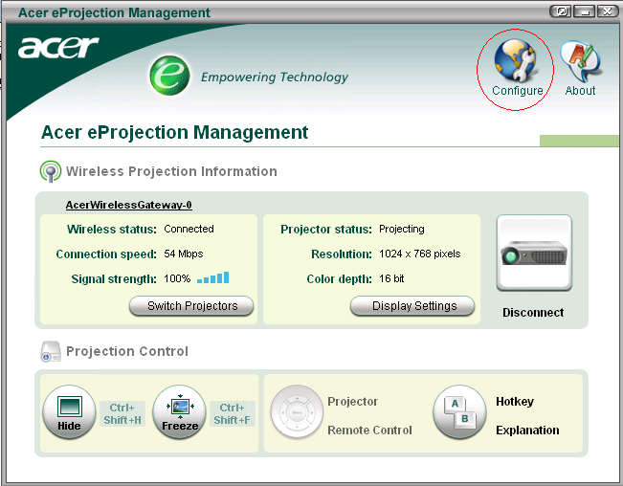
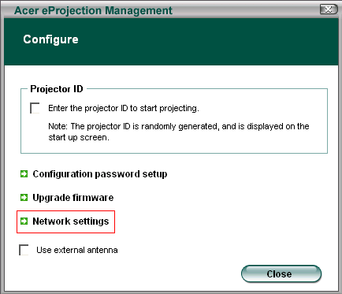

Please connect a network cable from a router with internet connection to the RJ45 port of your projector and setup an IP address, Netmask, Gateway and DNS as shown below, which works to your router.

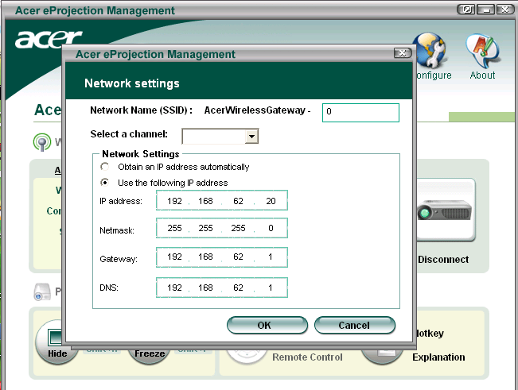

Restart the Acer eProjection Management Software.

Press the Configure button and choose Upgrade firmware.

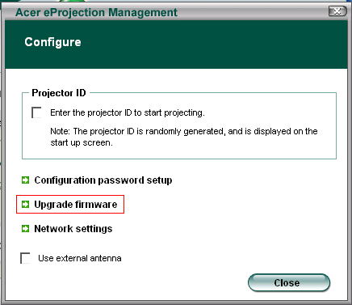
If the Internet connection works properly, you`ll get the following message.
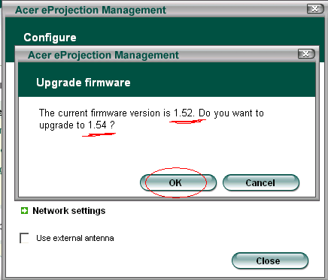
Upgrade to the latest firmware version by press on OK.
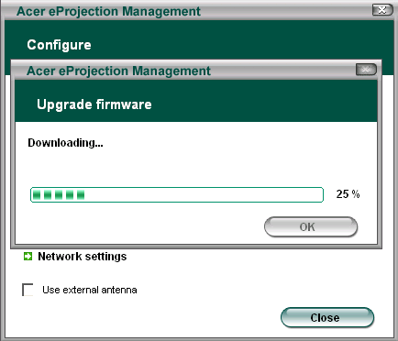
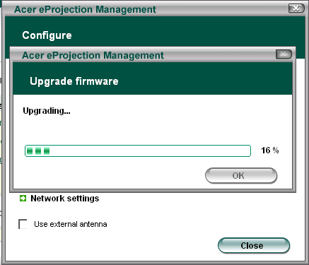
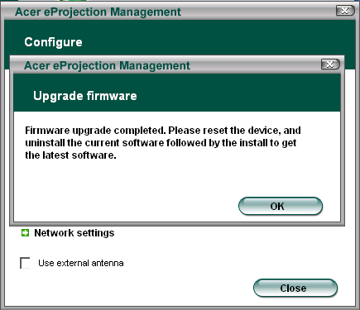
Uninstall the Acer eProjection Management Software and restart your PC and projector.
Reconnect the wireless gateway and install Acer eProjection Management Software (now ver. 1.54) for Windows Vista.

