VIA USB 2.0 Host Controller
Driver Installation Guide
(Version 1.0)
02/04/02
Contents
1.0 System Requirement ………………………………….P.3
2.0 Driver Limitations ……………………………………..P.3
3.0 Driver Installation (Windows XP) ……………………….P.4
4.0 Driver Installation (Windows 2000)…………………….P.10
5.0 Driver Installation (Windows ME)……………………P.13
6.0 Driver Installation (Windows 98/98SE)………………P.17

1.0 System Requirement
This setup program will install the driver for VIA USB 2.0 Host Controller. Before you start to run the setup program, please make sure your computer is an IBM PC-compatible system.

This driver can be used either the following operating systems:
- Windows98
- Windows98 Second Edition.
- Windows Millennium.
- Windows 2000.
- Windows XP.

2.0 Driver Limitations
Current limitations of the driver are: Composite devices and Hi-Speed Isochronous Transfers are currently not supported.

Please visit VIA web site (http://www.via.com.tw) to get the latest driver.

3.0 Driver Installation (Windows XP)
- Please make sure this PCI card has been installed on your system correctly.
Open the “Device Manager” and check if there is a “Universal Serial Bus (USB) Controller” in “Other devices”.
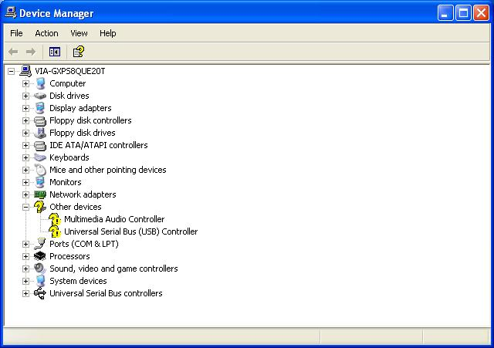

- Insert the supplied “Windows 98/ME/Win2K/WinXP USB 2.0 Driver Installation diskette” into the floppy disk drive and execute the setup program by double clicking on the “setup.exe” file in this diskette.

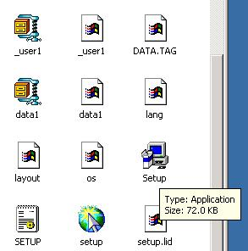
- Press “Next”.

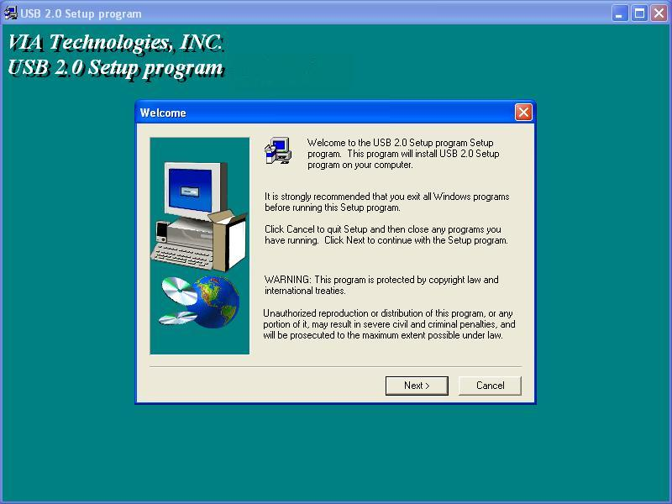

- Select “Install USB 2.0 Driver” and press “Next”.

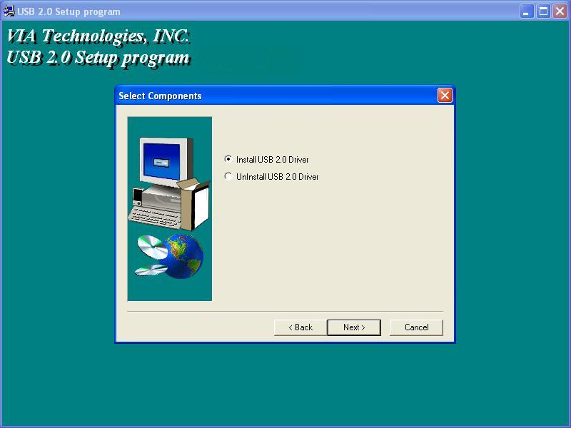
- Press “Continue Anyway”.

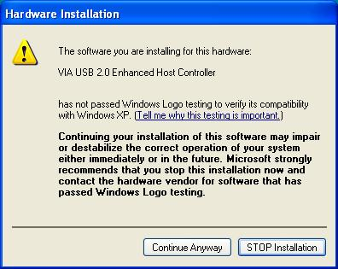

- Press “Next”.

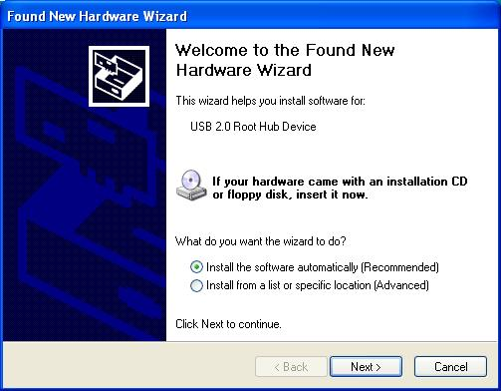
- Press “Continue Anyway”.

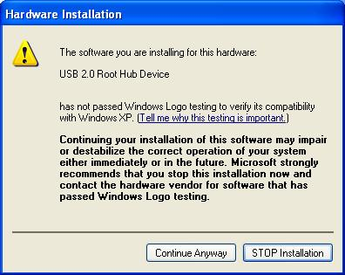

- Copy drivers for USB 2.0 Root Hub Device.

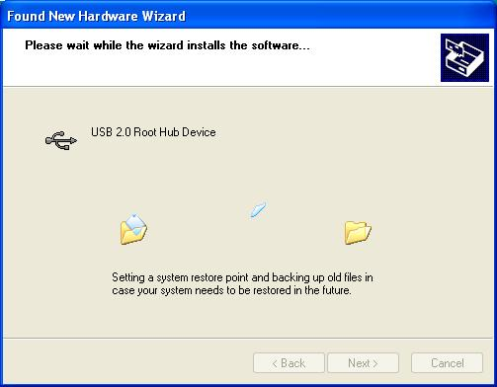
- Press “Finish”.

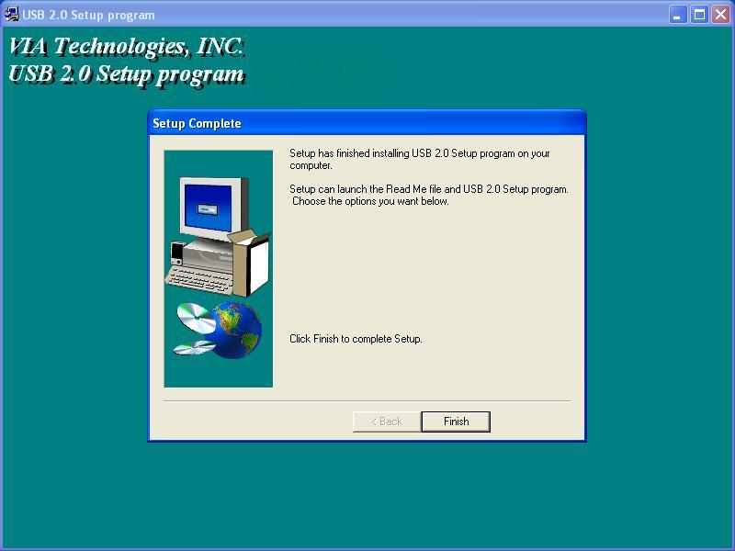

- Press “Finish”.

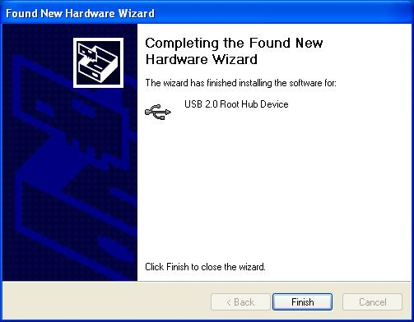
- Open “Device Manager” and check if your device works.
Note! If there is a yellow exclamation mark on “VIA USB 2.0 Enhanced Host Controller” or “USB 2.0 Root Hub Device”, please remove this item from the “Device Manager” by clicking the “Uninstall” button and click “Refresh” to re-install this driver again.

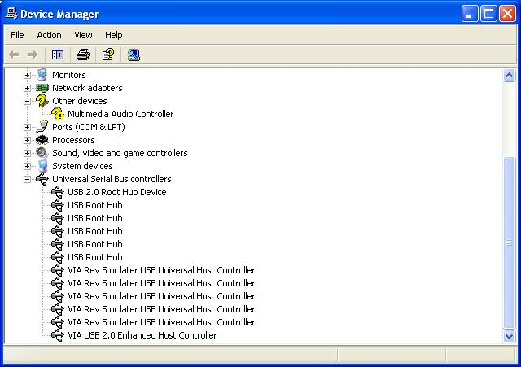

4.0 Driver Installation (Windows 2000)
- Please make sure this PCI card has been installed on your system correctly.
Open the Device Manager and check if there is a “Universal Serial Bus (USB) Controller” in “Other devices”.

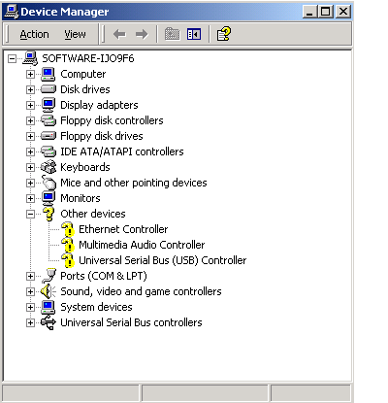
- Insert the supplied “Windows 98/ME/Win2K/WinXP USB 2.0 Driver Installation diskette” into the floppy disk drive and execute the setup program by double clicking on the “setup.exe” file in this diskette.

- Press “Next”.

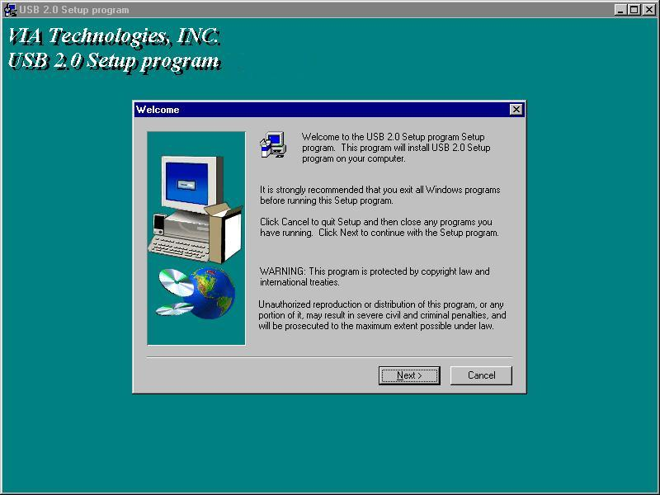

- Select “Install USB 2.0 Driver” and press “Next”.

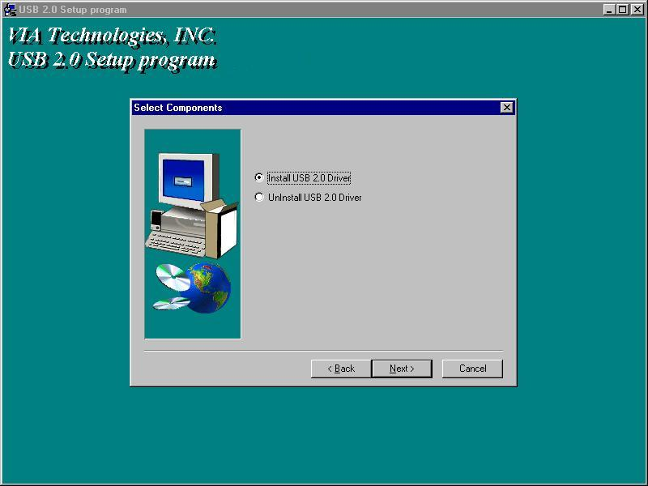
- Press “Finish”.
Note! This will restart your system. Please remember to close other programs before you click “Finish” button.
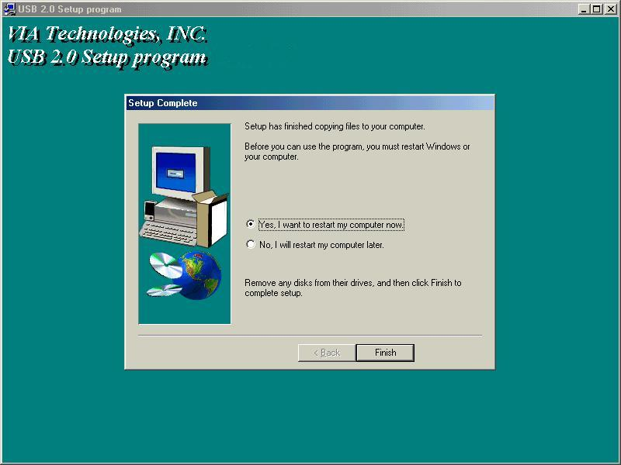

- After restarting your system, please check if your device works.
Note! If there is a yellow exclamation mark on “VIA USB 2.0 Enhanced Host Controller” or “USB 2.0 Root Hub Device”, please remove this item from the “Device Manager” by clicking the “Uninstall” button and click “Refresh” to re-install this driver again.
.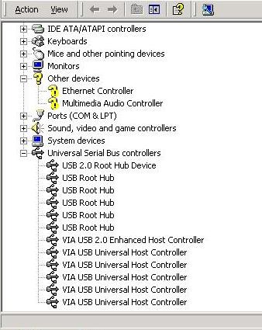
5.0 Driver Installation (Windows ME)
- Please make sure this PCI card has been installed on your system correctly.
Open the Device Manager and check if there is a yellow exclamation mark on one of the “VIA Tech 3038 PCI to USB Universal Host Controller” item.

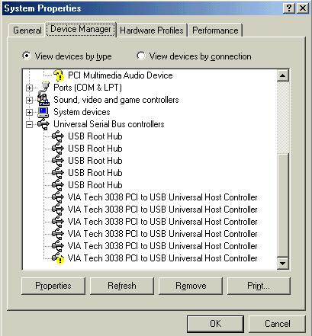

- Insert the supplied “Windows 98/ME/Win2K/WinXP USB 2.0 Driver Installation diskette” into the floppy disk drive and execute the setup program by double clicking on the “setup.exe” file in this diskette.

3. Press “Next”

- Select “Install USB 2.0 Driver” and press “Next”.

- Press “Finish”.
Note! This will restart your system. Please remember to close other programs before you click “Finish” button.

- After restarting your system, please check if your device works.
Note:
- If there is a yellow exclamation mark on “VIA USB 2.0 Enhanced Host Controller” or “USB 2.0 Root Hub Device”, please remove this item from the “Device Manager” by clicking the “Uninstall” button and click “Refresh” to re-install this driver again.
- The “green question mark” on “VIA USB 2.0 Enhanced Host Controller” item is not an error message. Please ignore it.

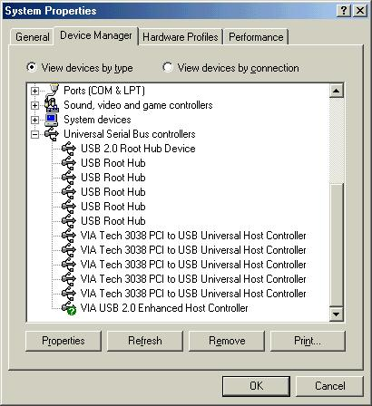
6.0 Driver Installation (Windows 98/98SE)
- Please make sure this PCI card has been installed on your system correctly.
Open the “Device Manager” and check if there is a “Universal Serial Bus (USB) Controller” in “Other devices”.

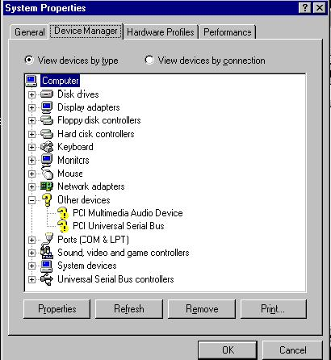

- Insert the supplied “Windows 98/ME/Win2K/WinXP USB 2.0 Driver Installation diskette” into the floppy disk drive and execute the setup program by double clicking on the “setup.exe” file in this diskette.
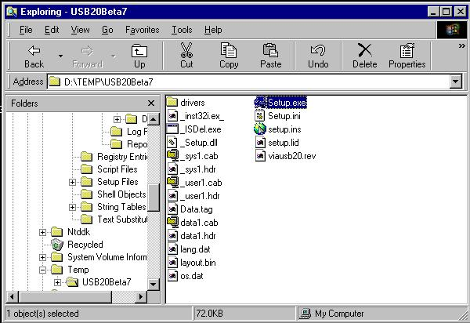
- Press “Next”.

- Select “Install USB 2.0 Driver” and press “Next”.

- Press “Finish”.
Note! This will restart your system. Please remember to close other programs before you click “Finish” button.

- After restarting your system, please check if your device works.
Note! If there is a yellow exclamation mark on “VIA USB 2.0 Enhanced Host Controller” or “USB 2.0 Root Hub Device”, please remove this item from the “Device Manager” by clicking the “Uninstall” button and click “Refresh” to re-install this driver again.

