WAP54G Upgrade Procedure

Introduction:

This document explains how to upgrade your WAP54G to firmware version 2.07.01
The procedure applies to V1.0 and V1.1 hardwares.

Before you begin:

Make sure you have:
- downloaded the required firmwares:
- Version 1.08.01: ftp://ftp.linksys.com/international/firmware/wap54g_eu_fw1.08.01.zip
- Version 1.09.1: ftp://ftp.linksys.com/pub/network/WAP54G_fw1.09.1.zip
- Version 2.07.01: ftp://ftp.linksys.com/international/firmware/wap54g_eu_2.07.01.zip

Step By Step Procedure:

Please follow carefully the following steps or you may damage your WAP54G.

- Setup your system to access AP’s HTML interface
- Fix the IP address & Gateway in the Network Properties. If your Gateway address is 192.168.1.245 (default) the IP address must be defined in the same subnet ie: 192.168.1.100
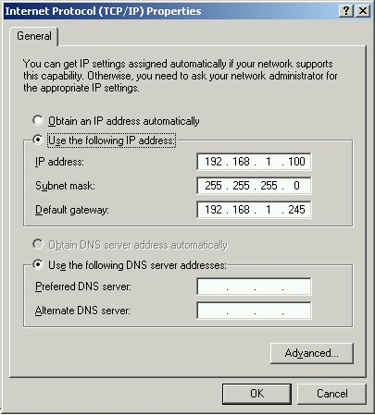

-Open your Web Browser, enter the AP Gateway IP address in the address field, press Enter. You’ll be prompted to enter your User Name and Password.
User Name = <blank>, Password = admin by default.
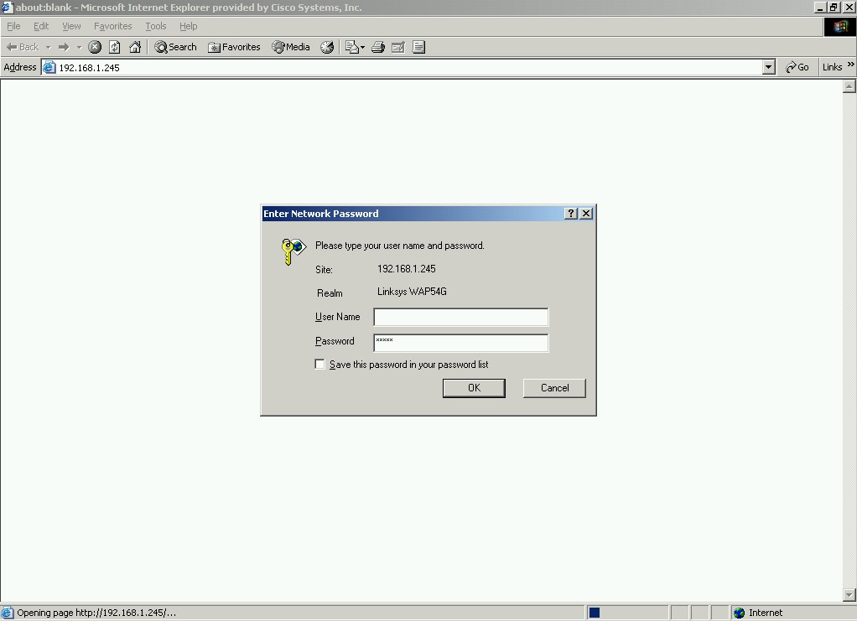

- Check the firmware version.
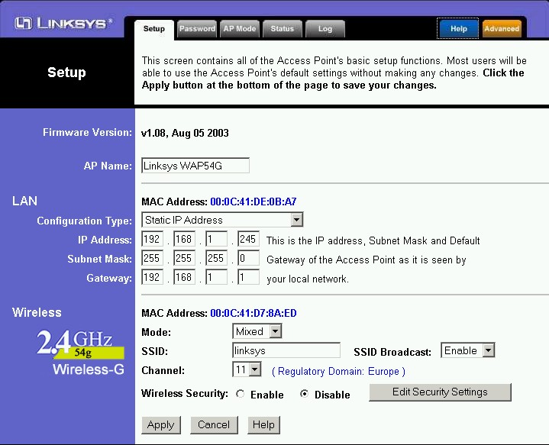

- Upgrade your AP.
  - If you firmware version is 1.06, upgrade your WPA54G to 1.08. If your firmware version is already 1.08, please proceed to step b.

- Click on the Help tab

-Click the Firmware Upgrade button. From Firmware Upgrade screen enter the location of the firmware’s file or click Browse button to find the file. Then click Upgrade button to upgrade the firmware.
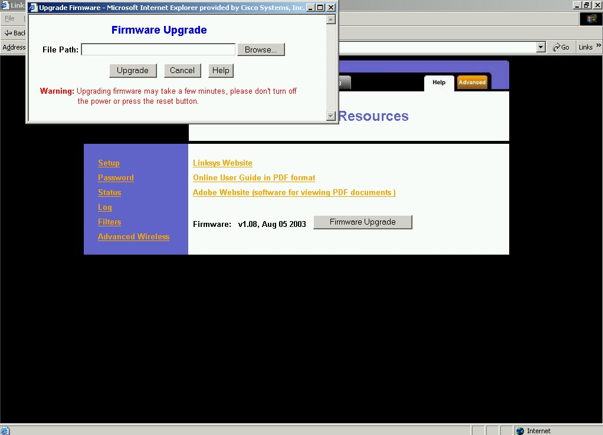

  - Upgrade to firmware 1.09.1
  - Upgrade to firmware 2.07.01

