- Double click on the modem patch ICON. It will be expanded and create “C:\NEC\CE.NET Modem Update” sub-directory.

- Backup all of your data on the MobilePro before attempting to update your system.

- Connect the external power adaptor to the system.

Note: The following step can be accomplished using either Active-Sync or removable storage media.

- Ensure that the following files are in the same folder on the MobilePro 900.
  - 0-7ff.s37
  - nvmlpe3_01-16_ver8.s37
  - PATCH9B52NVM.S37
  - ComNET_40611.exe

- Double tap the “ComNET_” ICON.

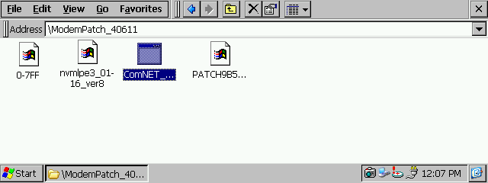

- The program should open and start running automatically.

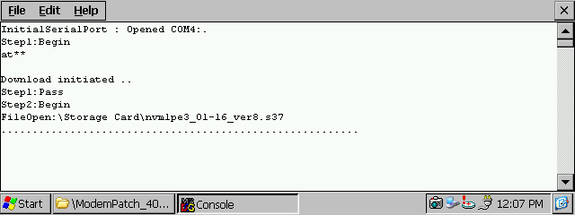

Note: Several screens will be displayed during the update process.

- The following screen will be displayed when the update is complete.

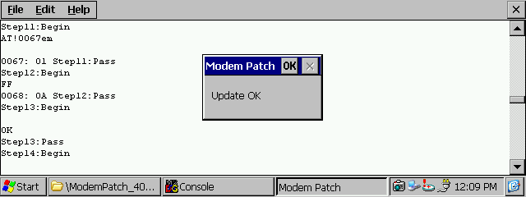

- Tap the ‘OK’ to close the window.
- Remove the external power adaptor.
- Momentary depress the “Pwr” to shut the system off.
- Momentary depress the “Pwr” to shut the system back on.
- The update process is complete and the modem is ready for use.
- If the files copied to the MobilePro in step 4 can be deleted, as they are not longer needed.

