Flash BIOS SOP
Flash SOP for DOS
(1)Execute DFB.bat in Dos
(2)After finish BIOS,Button “F1” to reboot system
(3)When system is on post screen,button “del” to go to BIOS Menu for loading default
(4)When go to BIOS menu,move to item “Load optimized defaults” ,button it , Dialog : Load optimized default(Y/N)? will pop up and choice “Y”
(5)After finish step(4),button “F10” , Dialog :Save to CMOS and EXIT (Y/N)? will pop up and choice “Y”
(6)After finish step(5),system will reboot and flash BIOS in DOS is finished
Flash SOP for Visat

(1) When system is on post screen,button “del” to go to BIOS Menu
(2) Move to item “Advanced BIOS Features, button it
(3) Move to item “BootBlock Write Protect”,change value to “disable”
(4) After finish step(3),button “F10” , Dialog :Save to CMOS and EXIT (Y/N)? will pop up and choice “Y” and go to Vista.
(5) Open the properties of Winflash.Pls refer to the pic. as below:
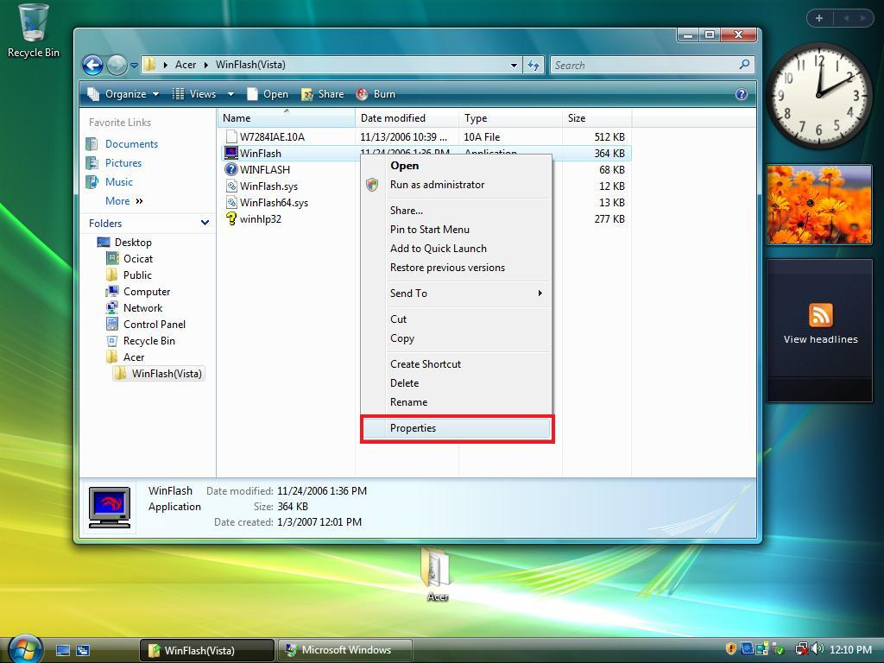
(6) Let item:”Run the programe as an administrator” in Compatibility enable. Pls refer to the pic as below
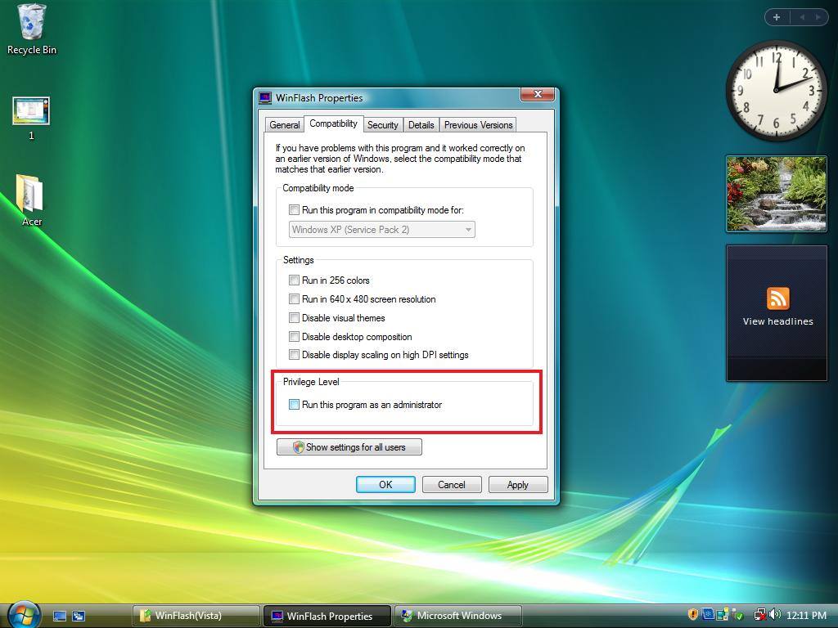

(7) Please execute WinFlash.exe
(8)open BIOS file
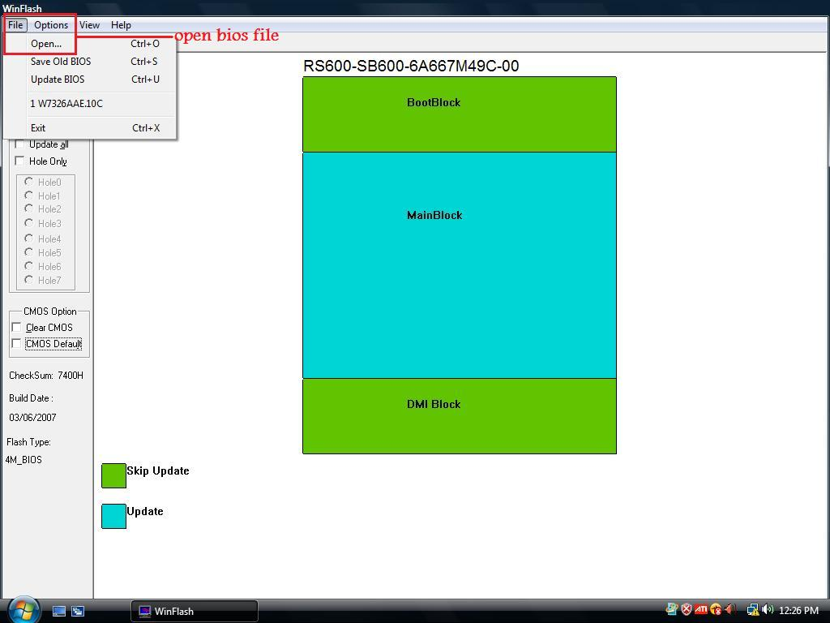
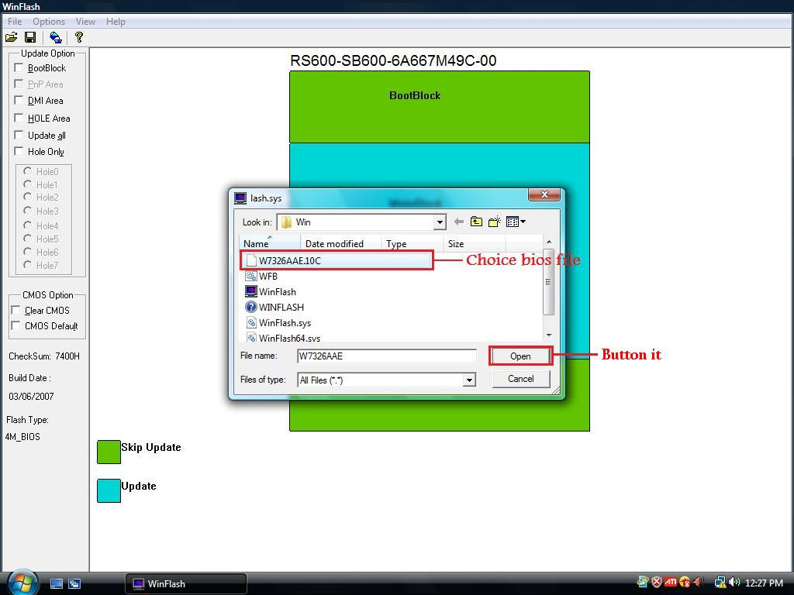
(9)Choice the update option and CMOS option
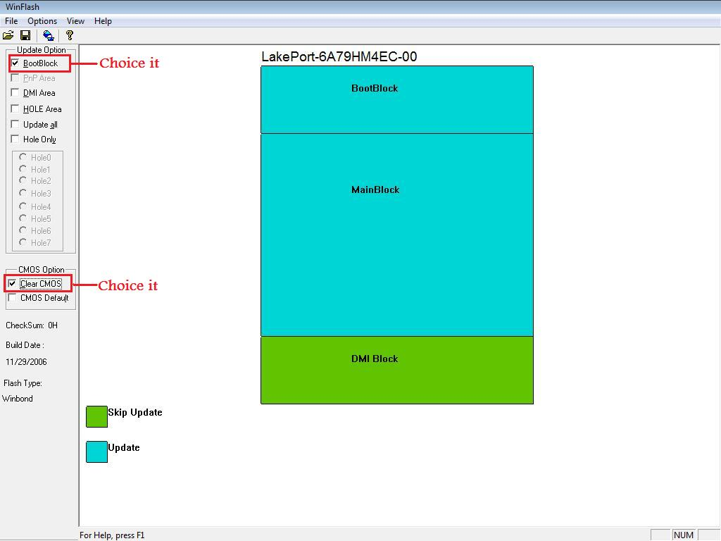
(10) flash BIOS
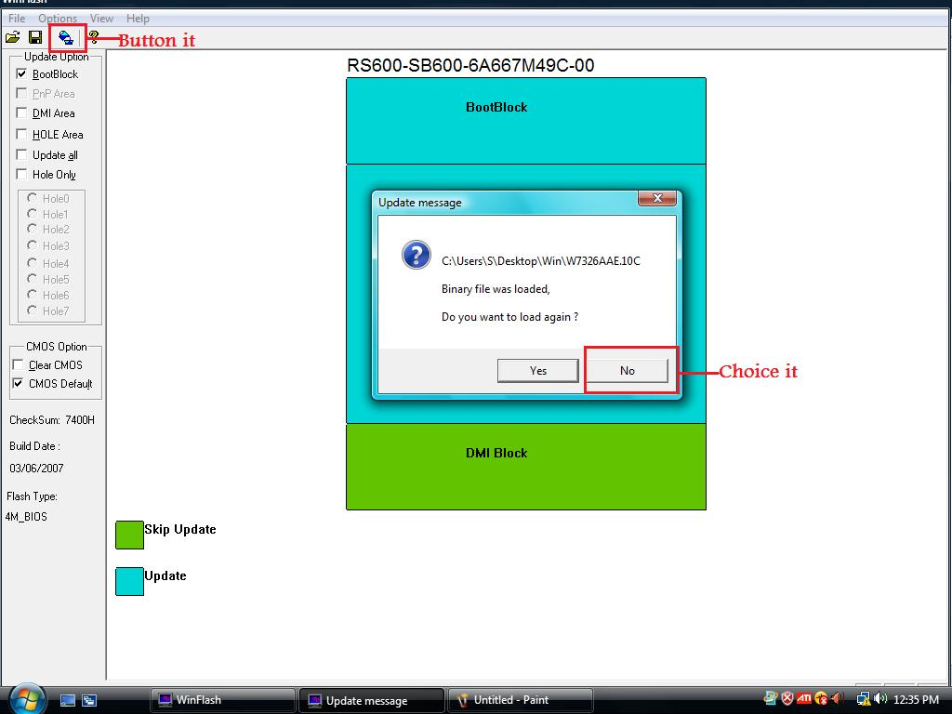
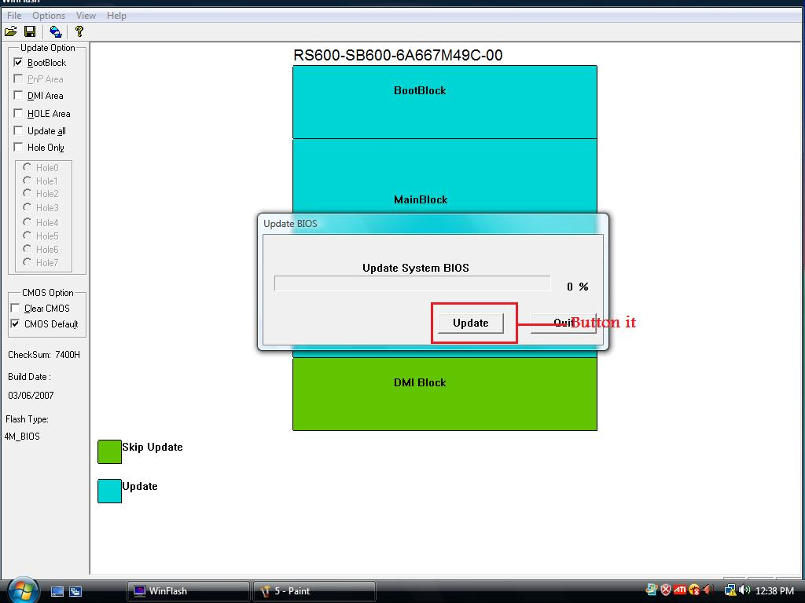
(11)Finish flash and restart system
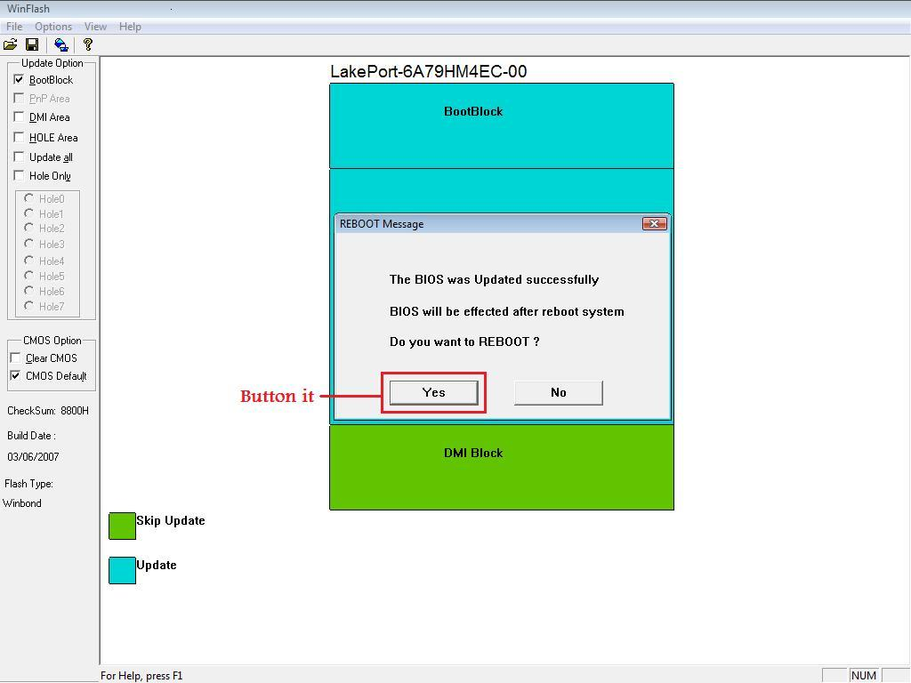

(12)When system reboot to post screen ,button “del” to go to BIOS Menu for loading default
(13)When go to BIOS menu ,move to item “Load optimized defaults” ,button it , Dialog :
Load optimized default(Y/N)? will pop up and choice “Y”
(14)After finish step (9),button “F10” , Dialog :Save to CMOS and EXIT (Y/N)? will pop up
and choice “Y”
(15)After finish step(10),system will reboot and flash BIOS in Vista is finished

Note:When flashing BIOS,remenber not to execute any programe for system if it will effect unexpected risk.

