(For Manual)

Declaration of Conformity

This device complies with Part 15 of the FCC Rules. Operation is subject to the following two conditions: (1) this device may not cause harmful interference, and (2) this device must accept any interference received, including interference that may cause undesired operation.

Product Name: Personal Computer
Model/ Type/ Machine Type: VT9100

Name of Responsible Party: Acer Inc.
Address of Responsible Party: 7 Hsin Ann Rd., Science-Based Industrial Park
Hsinchu 30077
Taiwan, R. O. C..

Contact Person: Angus Hsieh

Phone No.: 886-2-86911987
Fax No.: 886-2-86912641

We, Acer Incorporated, hereby declare that the equipment bearing the trade name and model number specified above was tested conforming to the applicable FCC Rules under the most accurate measurement standards possible, and that all the necessary steps have been taken and are in force to assure that production units of the same equipment will continue to comply with the Commissions requirements.

Acer Incorporated

ISL-01A003FB

Acer Incorporated
7 Hsin Ann Road

Science-Based Industrial Park
Hsinchu 300, Taiwan
R.O.C.
Telephone: (035) 770-707
Facsimile: (035) 778-500

Declaration of Conformity

This device complies with Part 15 of the FCC Rules. Operation is subject to the following two conditions: (1) this device may not cause harmful interference, and (2) this device must accept any interference received, including interference that may cause undesired operation.

Product Name: Personal Computer
Model/ Type/ Machine Type: VT9100

Name of Responsible Party: Acer Inc.
Address of Responsible Party: 7 Hsin Ann Rd., Science-Based Industrial Park
Hsinchu 30077
Taiwan, R. O. C..

Contact Person: Angus Hsieh

Phone No.: 886-2-86911987
Fax No.: 886-2-86912641

We, Acer Incorporated, hereby declare that the equipment bearing the trade name and model number specified above was tested conforming to the applicable FCC Rules under the most accurate measurement standards possible, and that all the necessary steps have been taken and are in force to assure that production units of the same equipment will continue to comply with the Commissions requirements.

Acer Incorporated

2001/01/17
--------------------------- ------------------
Angus Hsieh / Sr. Director Date
ISL-01A003FB
TEST REPORT

FOR

DECLARATION OF CONFORMITY

of

Personal Computer

Model/ Type/ Machine Type

VT9100

Applied by:

Acer Inc.
7 Hsin Ann Rd., Science-Based Industrial Park
Hsinchu 30077
Taiwan, R. O. C.

Test Performed by:
(NVLAP Lab. Code: 200234-0)

International Standards Laboratory

No. 21, Alley 37, Lane 122, Sec. 2
Hsiwan Rd. Hsichih Chen
Taipei Hsien 22117
Taiwan, R.O.C.

Tel:(02)2646-2550
Fax:(02)2646-4641

Contents of Report
1. General 1
1.1 Certification of Accuracy of Test Data 1
1.2 Summary 2
1.2.1 Description of Equipment Under Test (EUT) 2
1.2.2 Description of EUT and Support Equipment Included in Tests 2
1.2.3 Test Procedure and Specification 2
1.2.4 Tests Performed 2
2. Powerline Conducted Emissions 3
2.1 Configuration and Procedure 3
2.1.1 EUT Configuration 3
2.1.2 Test Procedure 3
2.1.3 EMI Receiver/Spectrum Analyzer Configuration (for the frequencies tested) 3
2.2 Test Data: CPU: PentiumIV-1.5 GHz, Power supply: Delta (Model:DPS-300GB-1D)300W, Hard disk driver: Seagate (Model:ST320420A)20GB, VGA Card: LEADTEK(Model: Winfast Geforce 2 MX), Resolution: 1280X1024 4
3. Open Field Radiated Emissions 6
3.1 Configuration and Procedure 6
3.1.1 EUT Configuration 6
3.1.2 Test Procedure 6
3.1.3 EMI Receiver/Spectrum Analyzer Configuration (for the frequencies tested) 6
3.2 Test Data:.CPU: PentiumIV-1.5 GHz, Power supply: Delta (Model:DPS-300GB-1D)300W, Hard disk driver: Seagate (Model:ST320420A)20GB, VGA Card: LEADTEK(Model: Winfast Geforce 2 MX), Resolution: 1280X1024 7
4. Appendix 9
4.1 Appendix A: Warning Labels 9
4.2 Appendix B: Warning Statement 10
4.3 Appendix C: Measurement Procedure for Powerline Conducted Emissions 11
4.4 Appendix D: Test Procedure for Radiated Emissions 12
4.5 Appendix E: Description of Open Field Test Site 13
4.6 Appendix F: Test Equipment 14
4.6.1 Test Equipment List 14
4.6.2 Software for Controlling Spectrum/Receiver and Calculating Test Data 15
4.7 Appendix G: Layout of EUT and Support Equipment 16
4.7.1 General Conducted Test Configuration 16
4.7.2 General Radiation Test Configuration 17
4.8 Appendix H: Description of Support Equipment 18
4.8.1 Description of Support Equipment 18
4.8.2 Software for Controlling Support Unit 22
4.8.3 I/O Cable Condition of EUT and Support Units 23
4.9 Appendix I: Description of Equipment Under Test 24
4.10 Appendix J: Accuracy of Measurement 26
4.11 Appendix K: Photographs of EUT Configuration Test Set Up 27
4.12 Appendix L: Photographs of EUT 29

General

Certification of Accuracy of Test Data

The electromagnetic interference tests which this report describes were conducted by an independent electromagnetic compatibility consultant, International Standards Laboratory in accordance with the test procedure specified in ANSI C63.4-1992, CFR 47 Part 15 Subpart B; or EN55022:1994/ A1:1995/A2:1997; CISPR 22:1993/A1:1995/A2:1996.

The test results contained in this report accurately represent the radiated, and power line conducted electromagnetic emissions generated by sample equipment under test at the time of the test.

Equipment Tested: Personal Computer
Model/ Type/ Machine Type: VT9100
Applied by Acer Inc.
Sample received Date: 2000/12/26

Final test Date : 2000/12/26
Temperature 23ºC(Conduction Test); 20ºC (Radiation Test)
Humidity: 63% (Conduction Test); 85% (Radiation Test)

Test Engineer: Chance Chan

The results show that the sample equipment tested as described in this report is in compliance with the Class B conducted and radiated emission limits of FCC Rules Part 15 Subpart B; or EN55022:1994/ A1:1995/ A2:1997; CISPR 22:1993/A1:1995/A2:1996.

Approve & Signature

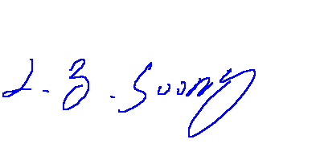

---------------------------------------
L. Y. Soong/Director

Test results given in this report apply only to the specific sample(s) tested under stated test conditions.
This report shall not be reproduced other than in full without the explicit written consent of ISL. This report totally contains 31 pages, including 1 cover page , 1 contents page, and 29 pages for the test description.
This report must not be use to claim product endorsement by NVLAP or any agency of the U.S. Government.

This test data shown below is traceable to NIST or national or international standard.
International Standards Laboratory certifies that no party to this application has been denied the FCC benefits pursuant to Section 5301 of the Anti-Drug Abuse Act of 1988, 21 U.S.C. 853(a).

Summary

Description of Equipment Under Test (EUT)

Description: Personal Computer
Model/ Type/ Machine Type: VT9100
Applicant: Acer Inc.
7 Hsin Ann Rd., Science-Based Industrial Park
Hsinchu 30077
Taiwan, R. O. C.
A more detailed, technical description of the EUT is contained in appendix H.

Description of EUT and Support Equipment Included in Tests

The EUT is a Personal Computer (Model/ Type/ Machine Type: VT9100), which was tested with the following support units:

- Acer Digital Camera Model: DVC-VII
- Microsoft Joy Stick Model: 90873
- Andrea Headphone Model: NC-80
- Koka Headphone Model: ST-8
- KOKA Microphone Model: DM-510
- KOKA Microphone Model: DM-510
- SONY radio cassette player Model: WM-FX50
- HP Printer Model: 2225C
- Logitech Mouse Model: M-S34
- Aceex Modem Model: DM1414
- Aceex Modem Model: DM1414
- Acer Monitor Model: 7377xe
- Acer Keyboard Model: 6511-TW4C
- IBM Personal Computer Model: IBM2170
- Acer USB Keyboard Model: 6511-UV
- Acer USB Mouse Model: M-U48a
- Acer USB Speaker Model: V-1

A more detailed technical description of the support equipment is contained in Appendix H.

Test Procedure and Specification

The tests were performed in accordance with ANSI C63.4-1992, CFR 47 Part 15 Subpart B; or EN55022:1994/ A1:1995/A2:1997; CISPR 22:1993/A1:1995/A2:1996 as detailed in Appendices C and D, and in the individual test sections. The test equipment used is detailed in Appendix F. The open field test site is described in Appendix E. The specification used was the Class B limits of FCC Rules Part 15 Subpart B.

Tests Performed

1. Powerline conducted emissions in shielded room.
See Part 2 of this report for full details.
- Radiated emissions in 10 meter open area.
See Part 3 of this report for full details.

Powerline Conducted Emissions

Configuration and Procedure

EUT Configuration

The conducted emission test setups are in accordance with Figs 9, 10(a) and 10(b) of ANSI C63.4-1992, CFR 47 Part 15 Subpart B; or EN55022:1994/ A1:1995/A2:1997; CISPR 22:1993/A1:1995/A2:1996.

The EUT was set up in the shielded room on the non-conductive table which is 1.0 by 1.5 meter, 80cm above ground. The wall of the shielded room was located 40cm to the rear of the EUT.

Power to the EUT was provided through the LISN. The impedance vs. frequency characteristic of the LISN is complied with the limit shown on the figure 1 of ANSI C63.4-1992.

Both lines (neutral and hot) were connected to the LISN in series at testing. A coaxial-type connector which provides a 50 OHM terminating impedance was provided for connecting the test instrument. The excess length of the power cord was folded back and forth at the center of the lead so as to form a bundle not exceeding 40cm in length.

Any changes made to the configuration, or modifications made to the EUT, during testing are noted in the following test record.

If the EUT is a Personal Computer or a peripheral of personal computer, and the personal computer has an auxiliary AC outlet which can be used for providing power to an external monitor, then all measurements will be made with the monitor power from first the computer-mounted AC outlet and then a floor-mounted AC outlet.

Test Procedure

The system was set up as described above, with the EMI diagnostic software running. The powerline conducted EMI tests were run on the hot and neutral conductors of the power cord and the results were recorded.

The highest emissions were analyzed in details by operating the spectrum analyzer in fixed tuned mode to determine the nature of the emissions and to provide information which could be useful in reducing their amplitude.

EMI Receiver/Spectrum Analyzer Configuration (for the frequencies tested)

Frequency Range: 150KHz--30MHz
Detector Function: Quasi-Peak / Average Mode
Bandwidth (RBW): 9KHz

Test Data: CPU: PentiumIV-1.5 GHz, Power supply: Delta (Model:DPS-300GB-1D)300W, Hard disk driver: Seagate (Model:ST320420A)20GB, VGA Card: LEADTEK(Model: Winfast Geforce 2 MX), Resolution: 1280X1024

Table 2.2.1 Power Line Conducted Emissions (Hot)
 |  | LISN |  | Quasi-Peak |  |  |  |  |  | Average
Frequency  (KHz/MHz) |  | Insertion Loss  (dB) |  | Amplitude  (dBuV) |  | Limit  (dBuV) |  | Margin  (dB) |  | Amplitude  (dBuV) |  | Limit  (dBuV) |  | Margin  (dB)
210.18KHz | 0.20 |  | 51.32 |  | 64.28 |  | -12.76 |  | 50.77 |  | 54.28 |  | -3.31
316.25KHz | 0.20 |  | 46.79 |  | 61.25 |  | -14.26 |  | 46.01 |  | 51.25 |  | -5.04
421.88KHz | 0.20 |  | 42.43 |  | 58.23 |  | -15.60 |  | 41.52 |  | 48.23 |  | -6.51
528.23KHz | 0.20 |  | 35.50 |  | 56.00 |  | -20.30 |  | 33.97 |  | 46.00 |  | -11.83
633.58KHz | 0.20 |  | 34.17 |  | 56.00 |  | -21.63 |  | 32.44 |  | 46.00 |  | -13.36
740.1KHz | 0.20 |  | 37.98 |  | 56.00 |  | -17.82 |  | 36.66 |  | 46.00 |  | -9.14
838.9KHz | 0.20 |  | 33.33 |  | 56.00 |  | -22.47 |  | 27.76 |  | 46.00 |  | -18.04
951.4KHz | 0.20 |  | 36.94 |  | 56.00 |  | -18.86 |  | 35.46 |  | 46.00 |  | -10.34
1.3718MHz | 0.24 |  | 38.06 |  | 56.00 |  | -17.70 |  | 36.73 |  | 46.00 |  | -9.03
2.1666MHz | 0.30 |  | 23.57 |  | 56.00 |  | -32.13 |  | 14.86 |  | 46.00 |  | -30.84
6.2055MHz | 0.41 |  | 47.32 |  | 60.00 |  | -12.27 |  | 42.09 |  | 50.00 |  | -7.50
12.667MHz | 0.71 |  | 26.00 |  | 60.00 |  | -33.29 |  | 17.03 |  | 50.00 |  | -32.26
29.922MHz | 1.00 |  | 32.25 |  | 60.00 |  | -26.75 |  | 25.93 |  | 50.00 |  | -23.07

* NOTE: Margin = Amplitude - Limit
A margin of -8dB means that the emission is 8dB below the limit

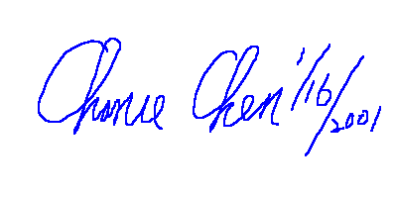
Tested by:

_________________________
Chance Chan
Table 2.2.1 Power Line Conducted Emissions (Neutral)
 |  | LISN |  | Quasi-Peak |  |  |  |  |  | Average
Frequency  (KHz/MHz) |  | Insertion Loss  (dB) |  | Amplitude  (dBuV) |  | Limit  (dBuV) |  | Margin  (dB) |  | Amplitude  (dBuV) |  | Limit  (dBuV) |  | Margin  (dB)
209.5KHz | 0.20 |  | 47.16 |  | 64.30 |  | -16.94 |  | 45.03 |  | 54.30 |  | -9.07
315.75KHz | 0.26 |  | 38.62 |  | 61.26 |  | -22.39 |  | 35.80 |  | 51.26 |  | -15.21
424.13KHz | 0.30 |  | 36.82 |  | 58.17 |  | -21.05 |  | 34.94 |  | 48.17 |  | -12.92
532.5KHz | 0.30 |  | 31.09 |  | 56.00 |  | -24.61 |  | 26.79 |  | 46.00 |  | -18.91
638.75KHz | 0.30 |  | 27.93 |  | 56.00 |  | -27.77 |  | 24.26 |  | 46.00 |  | -21.44
745.0KHz | 0.30 |  | 32.65 |  | 56.00 |  | -23.05 |  | 29.05 |  | 46.00 |  | -16.65
849.13KHz | 0.30 |  | 37.32 |  | 56.00 |  | -18.38 |  | 34.98 |  | 46.00 |  | -10.72
957.5KHz | 0.30 |  | 32.36 |  | 56.00 |  | -23.34 |  | 28.27 |  | 46.00 |  | -17.43
1.3625MHz | 0.30 |  | 26.46 |  | 56.00 |  | -29.24 |  | 20.61 |  | 46.00 |  | -25.09
2.16MHz | 0.31 |  | 21.41 |  | 56.00 |  | -34.28 |  | 13.91 |  | 46.00 |  | -31.78
6.22MHz | 0.44 |  | 27.56 |  | 60.00 |  | -32.00 |  | 20.35 |  | 50.00 |  | -29.22
12.672MHz | 0.50 |  | 20.83 |  | 60.00 |  | -38.67 |  | 14.21 |  | 50.00 |  | -35.29
29.927MHz | 0.60 |  | 32.59 |  | 60.00 |  | -26.81 |  | 26.12 |  | 50.00 |  | -23.28

* NOTE: Margin = Amplitude - Limit
A margin of -8dB means that the emission is 8dB below the limit

Tested by:

_________________________
Chance Chan

Open Field Radiated Emissions

Configuration and Procedure

EUT Configuration

The radiated emissions test setups are in accordance with Figs 10(c) and 10(d) of ANSI C63.4-1992, CFR 47 Part 15 Subpart B; or EN55022:1994/ A1:1995/A2:1997; CISPR 22:1993/A1:1995/A2:1996.

The equipment under test was set up on the 10 meter open field test non-conductive table 80cm above ground, same as conducted Excess data cable was folded back and forth to form a 30cm by 40cm bundle.

Any changes made to the configuration, or modifications made to the EUT, during testing are noted in the following test record.

If the EUT is a Personal Computer or a peripheral of personal computer, and the personal computer has an auxiliary AC outlet which can be used for providing power to an external monitor, then all measurements will be made with the monitor power from first the computer-mounted AC outlet and then a floor-mounted AC outlet.

Test Procedure

The system was set up as described above, with the EMI diagnostic software running. We found the maximum readings by varying the height of antenna and then rotating the turntable. Both polarization of antenna, horizontal and vertical, are measured.

The highest emissions between 30 MHz to 1000 MHz were also analyzed in details by operating the spectrum analyzer and/or EMI receiver in quasi-peak mode to determine the precise amplitude of the emissions. While doing so, the interconnecting cables and major parts of the system were moved around, the antenna height was varied between one and four meters, its polarization was varied between vertical and horizontal, and the turntable was slowly rotated, to maximize the emission. The highest emissions of frequency bigger than 1000 MHz was analyzed in peak mode to determine the precise amplitude of the emission.

EMI Receiver/Spectrum Analyzer Configuration (for the frequencies tested)

Frequency Range A: 30MHz--1000MHz
Detector Function: Quasi-Peak Mode
Bandwidth (RBW): 120KHz

Frequency Range B: 1000MHz--7000MHz
Detector Function: Peak Mode
Bandwidth (RBW): 1 MHz

Test Data:.CPU: PentiumIV-1.5 GHz, Power supply: Delta (Model:DPS-300GB-1D)300W, Hard disk driver: Seagate (Model:ST320420A)20GB, VGA Card: LEADTEK(Model: Winfast Geforce 2 MX), Resolution: 1280X1024
Table 3.2.1 Open Field Radiated Emissions (Horizontal)
Meter Reading |  |  |  | Correction Factor |  |  |  |  |  | Corrected Emissions |  |  |  |  |  |  | Antenna |  | Turntable
Freq.  (MHz) |  | Ampl.  (dBuV) |  | Ant.  (dB/m) |  | Cable  (dB) |  | Pre-Ampl.  (dB) |  | Ampl.  (dBuV/m) |  | Limit  (dBuV/m) |  | Margin*  (dB) |  | Height  (cm) |  |  | Position  (°)
175.0 | 12.19 |  | 8.75 |  | 2.48 |  | 0.00 |  | 23.42 |  | 30.00 |  | -6.58 |  | 100.00 |  |  | 0.00
394.78 | 14.26 |  | 15.59 |  | 3.89 |  | 0.00 |  | 33.74 |  | 37.00 |  | -3.25 |  | 170.00 |  |  | 108.00
460.6 | 13.12 |  | 16.36 |  | 4.20 |  | 0.00 |  | 33.68 |  | 37.00 |  | -3.32 |  | 225.00 |  |  | 73.00
493.44 | 11.22 |  | 17.48 |  | 4.47 |  | 0.00 |  | 33.16 |  | 37.00 |  | -3.84 |  | 170.00 |  |  | 56.00
526.26 | 9.37 |  | 18.28 |  | 4.58 |  | 0.00 |  | 32.23 |  | 37.00 |  | -4.77 |  | 400.00 |  |  | 84.00
539.47 | 8.05 |  | 18.57 |  | 4.61 |  | 0.00 |  | 31.23 |  | 37.00 |  | -5.77 |  | 400.00 |  |  | 80.00
592.37 | 8.76 |  | 18.63 |  | 4.86 |  | 0.00 |  | 32.25 |  | 37.00 |  | -4.75 |  | 400.00 |  |  | 100.00
789.62 | 5.56 |  | 20.32 |  | 6.08 |  | 0.00 |  | 31.96 |  | 37.00 |  | -5.04 |  | 400.00 |  |  | 50.00
995.07 | 5.08 |  | 21.36 |  | 7.42 |  | 0.00 |  | 33.86 |  | 37.00 |  | -3.14 |  | 400.00 |  |  | 100.00
1.1855GHz | 15.75 |  | 24.48 |  | 4.10 |  | 0.00 |  | 44.33 |  | 74.00 |  | -29.67 |  | 100.00 |  |  | 124.00
1.9741GHz | 14.20 |  | 27.20 |  | 5.43 |  | 0.00 |  | 46.83 |  | 74.00 |  | -27.17 |  | 100.00 |  |  | 216.20
2.1591GHz | 11.10 |  | 27.71 |  | 5.61 |  | 0.00 |  | 44.42 |  | 74.00 |  | -29.58 |  | 100.00 |  |  | 359.00
3.221GHz | 12.23 |  | 30.70 |  | 6.41 |  | 0.00 |  | 49.34 |  | 74.00 |  | -24.66 |  | 100.00 |  |  | 24.50

* NOTE: Margin = Corrected Amplitude – Limit
Corrected Amplitude = Radiated Amplitude + Antenna Correction Factor + Cable Loss – Pre-Amplifier Gain
A margin of -8dB means that the emission is 8dB below the limit
BILOG Antenna Distance: 10 meter, Frequency: under 1000MHz
Horn Antenna Distance: 3 meter, Frequency: 1000MHz—18GHz

Tested by:

_________________________
Chance Chan
Table 3.2.2 Open Field Radiated Emissions (Vertical)
Meter Reading |  |  |  | Correction Factor |  |  |  |  |  | Corrected Emissions |  |  |  |  |  |  | Antenna |  | Turntable
Freq.  (MHz) |  | Ampl.  (dBuV) |  | Ant.  (dB/m) |  | Cable  (dB) |  | Pre-Ampl.  (dB) |  | Ampl.  (dBuV/m) |  | Limit  (dBuV/m) |  | Margin*  (dB) |  | Height  (cm) |  |  | Position  (°)
79.949 | 13.30 |  | 6.49 |  | 1.55 |  | 0.00 |  | 21.34 |  | 30.00 |  | -8.66 |  | 100.00 |  |  | 255.00
159.72 | 14.19 |  | 9.32 |  | 2.29 |  | 0.00 |  | 25.80 |  | 30.00 |  | -4.20 |  | 100.00 |  |  | 285.00
208.87 | 13.61 |  | 8.74 |  | 2.71 |  | 0.00 |  | 25.06 |  | 30.00 |  | -4.94 |  | 100.00 |  |  | 75.00
427.67 | 7.26 |  | 15.91 |  | 4.05 |  | 0.00 |  | 27.22 |  | 37.00 |  | -9.78 |  | 100.00 |  |  | 139.00
460.58 | 9.47 |  | 16.36 |  | 4.20 |  | 0.00 |  | 30.03 |  | 37.00 |  | -6.97 |  | 328.00 |  |  | 87.00
495.28 | 6.93 |  | 17.54 |  | 4.48 |  | 0.00 |  | 28.95 |  | 37.00 |  | -8.05 |  | 400.00 |  |  | 90.00
526.31 | 6.83 |  | 18.28 |  | 4.58 |  | 0.00 |  | 29.69 |  | 37.00 |  | -7.31 |  | 400.00 |  |  | 97.00
539.87 | 4.74 |  | 18.58 |  | 4.62 |  | 0.00 |  | 27.93 |  | 37.00 |  | -9.07 |  | 400.00 |  |  | 0.00
559.29 | 8.05 |  | 18.76 |  | 4.69 |  | 0.00 |  | 31.50 |  | 37.00 |  | -5.50 |  | 345.00 |  |  | 99.00
789.93 | 7.00 |  | 20.32 |  | 6.08 |  | 0.00 |  | 33.40 |  | 37.00 |  | -3.60 |  | 400.00 |  |  | 50.00
1.5014GHz | 10.92 |  | 25.31 |  | 4.77 |  | 0.00 |  | 41.00 |  | 74.00 |  | -33.00 |  | 100.00 |  |  | 268.00
1.7047GHz | 8.33 |  | 26.12 |  | 4.98 |  | 0.00 |  | 39.42 |  | 74.00 |  | -34.58 |  | 100.00 |  |  | 3.20

* NOTE: Margin = Corrected Amplitude – Limit
Corrected Amplitude = Radiated Amplitude + Antenna Correction Factor + Cable Loss - Pre-Amplifier Gain
A margin of -8dB means that the emission is 8dB below the limit
BILOG Antenna Distance: 10 meter, Frequency: under 1000MHz
Horn Antenna Distance: 3 meter, Frequency: 1000MHz—18GHz

Tested by:

_________________________
Chance Chan

Appendix

Appendix A: Warning Labels

Label Requirements

A Class B digital device subject to Declaration of Conformity of FCC shall carry a label which includes the following statement:

The sample label shown shall be permanently affixed at a conspicuous location on the device and be readily visible to the user at the time of purchase.



Appendix B: Warning Statement

Statement Requirements

The operators manual for a Class B digital device shall contain the following statements or their equivalent:

* * * W A R N I N G * * *

This equipment has been tested and found to comply with the limits for a Class B digital device, pursuant to Part 15 of the FCC Rules. These limits are designed to provide reasonable protection against harmful interference when the equipment is operated in a residential installation. This equipment generates, uses, and can radiate radio frequency energy and if not installed and used in accordance with the instruction manual may cause harmful interference to radio communications. However, there is no guarantee that interference will not occur in a particular installation. If this equipment does cause harmful interference to radio or television reception, which can be determined by turning the equipment off and on, the user is encouraged to try to correct the interference by one or more of the following measures:

- Reorient or relocate the receiving antenna.

- Increase the separation between the equipment and receiver.

- Connect the equipment into an outlet on a circuit different from that to which the receiver is connected.

- Consult the dealer or an experienced radio TV technician for help.

Notice: The changes or modifications not expressly approved by the party responsible for compliance could void the user's authority to operate the equivalent.

* * * * * * * * *

If the EUT was tested with special shielded cables the operators manual for such product shall also contain the following statements or their equivalent:

Shielded interface cables and/or AC power cord, if any, must be used in order to comply with the emission limits.

Appendix C: Measurement Procedure for Powerline Conducted Emissions

The EUT is set up in accordance with the suggested configuration given in ANSI C63.4-1992, CFR 47 Part 15 Subpart B; or EN55022:1994/A1:1995/A2:1997; CISPR 22:1993/A1:1995/A2:1997. The measurements are performed in a 3.5 x 3.4 x 2.5 (m) shielded room. The EUT was placed on a non-conduction 1.0 x 1.5 (m) table, which is 0.8 meters above an earth-grounded.

Power to the EUT was provided through the LISN which has the Impedance vs. Frequency Characteristic in accordance with the Figure 1 of the ANSI C63.4-1992. Power to the LISNs were filtered to eliminate ambient signal interference and these filters were bonded to the ground plane. Peripheral equipment required to provide a functional system (support equipment) for EUT testing was powered from the second LISN through a ganged, metal power outlet box which is bonded to the ground plane at the LISN.

If the EUT is supplied with a flexible power cord, the power cord length in excess of the distance separating the EUT from the LISN shall be folded back and forth at the center of the lead so as to form a bundle not exceeding 40cm in length. If the EUT is provided with a permanently coiled power cord, bundling of the cord is not required. If the EUT is supplied without a power cord, the EUT shall be connected to the LISN by a power cord of the type specified by the manufacturer which shall not be longer than 1 meter. The excess power cord shall be bundled as described above. If a non-flexible power cord is provided with the EUT, it shall be cut to the length necessary to attach the EUT to the LISN and shall not be bundled.

The interconnecting cables were arranged and moved to get the maximum according to ANSI C63.4-1992, CFR 47 Part 15 Subpart B; or EN55022:1994/A1:1995/A2:1997; CISPR 22:1993/A1:1995/A2:1997. Both the line of power cord, hot and neutral, were measured.

The highest emissions were analyzed in details by operating the spectrum analyzer in fixed tuned mode to determine the nature of the emissions and to provide information which could be useful in reducing their amplitude.

Appendix D: Test Procedure for Radiated Emissions

Preliminary Measurements in the Anechoic Chamber

The radiated emissions are initially measured in the anechoic chamber at a measurement distance of 3 meters. Desktop EUTs are placed on a wooden stand 0.8 meter in height. The measurement antenna is 3 meters from the EUT. The test setup in anechoic chamber is the same as open site. The turntable rotated 360°C. The antenna height is varied from 1-2.5m. The primary objective of the radiated measurements in the anechoic chamber is to identify the frequency spectrum in the absence of the electromagnetic environment existing on the open test site. The frequencies can then be preselected on the open test site to obtain the corresponding amplitude. The initial scan is made with the spectrum analyzer in automatic sweep mode. The spectrum peaks are then measured manually to determine the exact frequencies.

Measurements on the Open Site

The radiated emissions test will then be repeated on the open site to measure the amplitudes accurately and without the multiple reflections existing in the shielded room. The EUT and support equipment are set up on the turntable of one of the 3 or 10 meter open field sites. Desktop EUTs are set up on a wooden stand 0.8 meter above the ground.

For the initial measurements, the receiving antenna is varied from 1-4 meter height and is changed in the vertical plane from vertical to horizontal polarization at each frequency. Both reading are recorded with the quasi-peak detector and with the 120 kHz bandwidth. For frequency between 30 MHz and 1000MHz, the reading are recorded with peak detector and with the 1 MHz bandwidth.

At the highest amplitudes observed, the EUT is rotated in the horizontal plane while changing the antenna polarization in the vertical plane to maximize the reading. The interconnecting cables were arranged and moved to get the maximum according to ANSI C63.4-1992, and/or EN55022:1994/A1:1995/A2:1997 / CISPR 22:1993/A1:1995/A2:1996. Once the maximum reading is obtained, the antenna elevation and polarization will be varied between specified limits to maximize the readings.

During the open site measurements, the peaks are selected, the scan frequency span width is reduced to 0--1MHz, the audible modulation is monitored with a loudspeaker and the quasi-peak reading or peak is recorded at the indicated frequency and at the specified bandwidth.

Appendix E: Description of Open Field Test Site

The open field test site is located on a valley in Hsichih Chen and adjacent to Taipei City. The direct distance to Taipei City is about 12 Km. It is surrounded by hills measuring about 100 meters high.

The test platform is located on the top of the office building, approximately 12 meters wide and 17 meters long. The platform is located on the top of a very large ground metal plane to enhance a homogeneous reflective surface according to ANSI C63.4-1992, CFR 47 Part 15 Subpart B; or EN55022:1994/ A1:1995/A2:1997; CISPR 22:1993/A1:1995/A2:1996.

The office building houses the test laboratory, the shielded room, for performing Line conducted test, test personal and other support staff.

Appendix F: Test Equipment

Test Equipment List

Use  For | Equipment | Brand | Model | Start  Service Date | Last  Cal. Date | Next  Cal. Date
R.C, U | Spectrum Analyzer | HP | 8568B, rev: 7.4.87  S/N: 2648A14610 | Nov. 25, 1990 | Aug. 22, 2000 |  | Feb. 22, 2001
R.C, U | Quasi-Peak Adapter | HP | 85650A  S/N: 2811A01188 | Nov. 25, 1990 | Aug. 22, 2000 |  | Feb. 22, 2001
R.C, U | RF Pre-selector | HP | 85685A  S/N: 2837A00816 | Nov. 25, 1990 | Aug. 22, 2000 |  | Feb. 22, 2001
R.C, U | Spectrum Analyzer | HP | 8568B, rev: 7.4.87  S/N: 2601A02356 | Nov. 25, 1990 | Sep. 05, 2000 |  | Mar. 05, 2001
R.C, U | Quasi-Peak Adapter | HP | 85650A  S/N: 2521A00708 | Nov. 25, 1990 | Sep. 05, 2000 |  | Mar. 05, 2001
R.C, U | RF Pre-selector | HP | 85685A  S/N: 2602A00240 | Nov. 25, 1990 | Sep. 05, 2000 |  | Mar. 05, 2001
R | EMI Receiver | R&S | ESMI; rev. 02.80  S/N: 849182/003 | Nov. 09, 1999 | Oct. 23, 2000 |  | Apr. 22, 2001
R, C | EMI Receiver | HP | 8546A;  S/N: 3441A00208 | Sep. 08, 1997 | Dec. 13, 2000 |  | Dec. 13, 2001
R, C, U | EMI Receiver | HP | 8546A;  S/N: 3520A00236 | Oct. 28, 2000 | Oct. 27, 2000 |  | Oct. 27, 2001
R, U | BILOG Antenna | Chase | CBL6112  S/N: 2077 | Oct. 20, 1997 | Jan. 27, 2000 |  | Jan. 26, 2003
R | BILOG Antenna | Chase | CBL6112B  S/N: 2487 | Nov. 23, 1998 | Nov. 03, 2000 |  | Nov. 02, 2001
R | Horn Antenna | EMCO | 3115  S/N: 9504-4462 | Nov. 06, 1999 | Dec. 02, 2000 |  | Dec.01, 2001
R, U | Horn Antenna | COM-Power | AH-118  S/N: 10088 | Jan. 20, 2000 | Jan. 20, 2000 |  | Jan. 19, 2003
 | Dipole Antenna | Schwarzbeck | VHAP  S/N: 918, 919 | Jun. 01, 1999 | Jun. 01, 1999 |  | Jun. 01, 2002
 | Dipole Antenna | Schwarzbeck | UHAP  S/N: 901, 902 | Jun. 01, 1999 | Jun. 01, 1999 |  | Jun. 01, 2002
C | LISN 1 | R & S | ESH2-Z5  S/N: 890485/013 | Dec. 15, 1988 | Oct. 27, 2000 |  | Oct. 27, 2001
C | LISN 2 | EMCO | 3825/2  S/N: 1407 | Oct. 20, 1990 | Oct. 27, 2000 |  | Oct. 27, 2001
C | Terminator | RICHTEC | S/N: ISL-T-001 | Oct. 19, 1999 | Apr. 29, 2000 |  | Apr. 28, 2001
C | Terminator | RICHTEC | S/N: ISL-T-002 | Oct. 19, 1999 | Apr. 29, 2000 |  | Apr. 28, 2001
R | Coaxial Cables | RICHTEC | TWB4001  S/N: 3F-10 | Aug. 31, 1995 | Jul. 24, 2000 |  | Jul. 24, 2001
R | Coaxial Cables | RICHTEC | 9913 (CB03)  S/N: 3F-3 | Dec. 20, 1998 | Apr. 19, 2000 |  | Apr. 19, 2001
C | Coaxial Cables | RICHTEC | RG400  S/N: 1F-C1 | Aug. 31, 1995 | Feb. 28, 2000 |  | Feb. 28, 2001
C | Coaxial Cables | RICHTEC | RG400  S/N: 1F-C2 | Aug. 31, 1995 | Feb. 28, 2000 |  | Feb. 28, 2001
R | Computer/Controller | Acer | Acer PC  S/N: ISLPC3 | Mar. 31, 1999 | N/A |  | N/A
 | Computer/Controller | Acer | Acer PC  S/N: ISLPC2 | Aug. 31, 1998 | N/A |  | N/A
C | Computer/Controller | Acer | Acer PC  S/N: ISLPC1 | May. 20, 1998 | N/A |  | N/A
 | Anechoic Chamber | NA | ISL-SR100 (7.6X5.7X5M)  S/N: ISL001 | Jul. 26, 1995 | Jul. 18, 2000 |  | Jul. 17, 2001
 | Coaxial Cables | RICHTEC | RG 213U  S/N: 1F-3 | Jul. 26, 1995 | Jul. 18, 2000 |  | Jul. 18, 2001
 | Field Site Source | COM-Power | CG-505  S/N: 18013 | Oct. 30, 1999 | N/A |  | N/A
 | Signal Generator | HP | 8648B  S/N: 3642U01040 | Jun. 30, 1997 | Jul. 22, 2000 |  | Jul. 22, 2001
R | Thermo-Hygro Meter | CRECER | HD-30  S/N: ISL-C-001 | Nov. 26, 1999 | Nov. 28, 2000 |  | Nov. 27, 2001
C | Digital Thermo-Hygro Meter | MICROLIFE | S/N: ISL-C-002 | Nov. 26, 1999 | Nov. 28, 2000 |  | Nov. 27, 2001

Note:

Calibration traceable to NIST or national or international standards.

***: The equipment is sent for calibration.
The Use For column with C means the equipment is used for the measurement of conducted emission.
The Use For column with R means the equipment is used for the measurement of conducted emission.
The Use For column with U means the equipment is used as a spare equipment for the measurement when equipment sent for calibration.

Software for Controlling Spectrum/Receiver and Calculating Test Data
Radiation/Conduction | Filename | Version | Issued Date
Conduction | 97CEMI.EXE | 2.0 | 10/8/97
Radiation | 97XEMI.EXE | 3.3 | 3/21/97

Appendix G: Layout of EUT and Support Equipment

General Conducted Test Configuration

Shielded Room

40 cm

Load
Active
EUT

LISN
Non-Conducted Table

80 cm

LISN

Metal Ground Plane
Filter

Filter

Printer
Spectrum
Control PC

General Radiation Test Configuration

10 M

Antenna Mast Broadband or Dipole Antenna Antenna height can be moved from 1 m to 4 m, Antenna and turntable distance 3 m to 10 m.
Non-Conducted
Table
To Spectrum

80 cm To Remote
Controller

To Remote Controller
Load
Active
EUT
Printer
Spectrum
Control PC
Remote
Controller

Metal Full Soldered Ground Plane

To turntable
To Antenna

To Antenna

Appendix H: Description of Support Equipment

Description of Support Equipment

- Description: Acer Digital Camera
Model: DVC-VII
Serial Number: N/A
Power Supply Type: From PC USB Port
Power Cord: N/A
FCC ID: (Comply with FCC DOC)
- Description: Microsoft Joy Stick
Model Number: 90873
Serial Number: 01151545
Power Supply Type: N/A
Power Cord: N/A
FCC ID: C3KMGP1
- Description: Andrea Headphone
Model Number: NC-80
Serial Number: N/A
Power Supply Type: N/A
Power Cord: N/A
FCC ID: N/A
- Description: Koka Headphone
Model Number: ST-8
Serial Number: N/A
Power Supply Type: N/A
Power Cord: N/A
FCC ID: N/A
- Description: KOKA Microphone
Model Number: DM-510
Serial Number: N/A
Power Supply Type: N/A
Power Cord: N/A
FCC ID: N/A
- Description: KOKA Microphone
Model Number: DM-510
Serial Number: N/A
Power Supply Type: N/A
Power Cord: N/A
FCC ID: N/A
- Description: SONY radio cassette player
Model Number: WM-FX50
Serial Number: N/A
Power Supply Type: N/A
Power Cord: N/A
- Description: HP Printer
(for parallel interface port)
Model Number: 2225C
Serial Number: N/A
Power Supply Type: Switching
(AC to AC Xfmr, Wall Mounted Type)
Power Cord: Nonshielded, Detachable
With Grounding Pin
FCC ID: DSI6XU2225
- Description: Logitech Mouse
Model Number: M-SAH
Serial Number: LZB81251703
Power Supply Type: N/A
Power Cord: N/A
FCC ID: DZL211029
- Description: Aceex Modem
(for serial interface port 1)
Model Number: DM1414
Serial Number: 960063772
Power Supply Type: Linear, Power Adapter
( AC to AC Xfmr, Wall Mounted Type )
Power Cord: Nonshielded, Without Grounding Pin
FCC ID: IFAXDM1414
- Description: Aceex Modem
(for serial interface port 2)
Model Number: DM1414
Serial Number: 960063771
Power Supply Type: Linear, Power Adapter
( AC to AC Xfmr, Wall Mounted Type )
Power Cord: Nonshielded, Without Grounding Pin
FCC ID: IFAXDM1414
- Description: Acer Monitor
Model: 7377xe
Serial Number: 999027100501700055P644E1 P
Power Supply Type: Switching
Power Cord: Nonshielded, Detachable
FCC ID: (Comply with FCC DOC)
- Description: Acer Keyboard
Model Number: 6511-TW4C
Serial Number: 916600704C83D11076S00000
Power Supply Type: N/A
Power Cord: N/A
FCC ID: JVPKBS-WIN
- Description: Personal Computer
Model: IBM 2170
Serial No.: N/A
Power Supply Type : Switching
Delta (Model: DPS-145PB-80A)
Hard Disk Drive: Maxtor (Model: 91303D6) 13.3GB
Floppy Driver: Panasonic (Model: JU256A276P )
CD-ROM Drive: AOpen (Model: CD-940E/TKU PRO)
ZIP Driver: Iomega (Model:Z100ATAPI)
LAN Card Accton (Model: EN1207D-TX1)
FDD/HDD Controller and
VGA port/ Parallel/
Serial port: Built on Motherboard
VGA port: one 15-pin
Parallel Port: one 25-pin
Serial Port: one 9-pin
Keyboard Connector: 6-pin
Mouse Connector: 6-pin
USB Connector: two 4-pin
Game Port: one 15-pin
Speaker Port: one
Microphone Port: one
Line In Port: one
Power Cord: Nonshielded, Detachable
FCC ID: N/A (comply witch FCC DOC)

- Description: Acer USB Keyboard
Model Number: 6511-UV
Serial Number: N/A
Power Supply Type: N/A
Power Cord: N/A
FCC ID: N/A(comply with FCC DOC)
- Description: Acer USB Mouse
Model: M-U48a
Serial Number: LZE01267035
Power Supply Type: N/A
Power Cord: N/A
FCC ID: JNZ211360

- Description: Acer USB Speaker
Model Number: V-1
Serial Number: N/A
Power Supply Type: N/A
Power Cord: N/A
FCC ID: (Comply with FCC DOC)

Software for Controlling Support Unit
A test program which generates a complete line of continuously repeating "H" pattern is used as the software test program. The program was executed as follows:

- Read and write to the disk drives.
- Capture Video image from digital camera than playback to display.
- Send audio signal to the speaker.
- Send audio signal to the headphone.
- Send audio signal to the headphone.
- Receive audio signal from the microphone.
- Receive audio signal from the microphone.
- Receive audio signal from walkman.
- Send H pattern to the parallel port device (Printer).
- Send H pattern to the serial port device (Modem 1).
- Send H pattern to the serial port device (Modem 2).
- Send H pattern to the video port device (Monitor).
- Send H pattern to server and receive H pattern from server.
- Repeat the above steps.

 | Filename | Issued Date
LAN | EMC.exe | 11/22/1996
Monitor | HH.bat | 8/20/1991
Modem 1 | Hm.bat | 8/20/1991
Modem 2 | Hm.bat | 8/20/1991
Printer1 | Wordpad.exe | 11/11/1999
Digital Camera | Acer Cap.exe | 8/10/1998

I/O Cable Condition of EUT and Support Units
Description | Path | Cable Length | Cable Type | Connector Type
AC Power Cord | 110V (~240V) to AC Power Cord Inlet (3-pin) | 1.8M | Nonshielded, Detachable | Plastic Head  Plastic Hood
Telephone Line | RJ 11 Connector to 600Ω Load | 1.2M | Nonshielded, Detachable to PC | Plastic Head  Plastic Hood
Server Data Cable | Server to EUT LAN port | 33 feet | Shielded, Detachable | RJ-45, with Metal Head, Metal Hood
Keyboard Data Cable | Keyboard to PC Keyboard port | 1.8M | Shielded, Undetachable | Metal Head  Plastic Hood
Monitor Data Cable | Monitor to PC VGA port | 1.6M | Shielded, Detachable | Metal Head  Plastic Hood
Modem Data Cable | Modem to PC COM 1 port | 1.5M | Shielded, Detachable | Metal Head  Metal Hood
Modem Data Cable | Modem to PC COM 2 port | 1.5M | Shielded, Detachable | Metal Head  Metal Hood
Mouse Data Cable | Mouse to PC Mouse port | 1.8M | Shielded, Undetachable | Metal Head  without Hood
Printer Data Cable | Printer to PC Parallel port | 1.5M | Shielded, Detachable | Metal Head  Plastic Hood
Audio-in Data Cable | Walkman to PC Audio-In Port | 1.5M | Nonshielded, Detachable to PC | Metal Head  Plastic Hood
Microphone Data Cable | Microphone to Mic Jack of PC | 1.5M | Nonshielded, Undetachable | Metal Head  Plastic Hood
Microphone Data Cable | Microphone to Mic Jack of PC | 1.5M | Nonshielded, Undetachable | Metal Head  Plastic Hood
Headphone Data Cable | Headphone to Line-out jack of PC | 1.5M | Nonshielded, Undetachable | Metal Head  without Hood
Headphone Data Cable | Headphone to Line-out jack of PC | 1.5M | Nonshielded, Undetachable | Metal Head  without Hood

Joy Stick Data Cable | Joystick to PC Joystick port | 1.2M | Nonshielded, Undetachable | Metal Head  without Hood
USB CCD Data Cable | Digital camera to PC USB port | 1.6M | Shielded, Detachable | Metal Head  Plastic Hood
USB Speaker Data Cable | Speaker to PC line-out port | 1.5M | Nonshielded, Undetachable | Metal Head  without Hood

Appendix I: Description of Equipment Under Test

EUT

Description: Personal Computer
Condition: Pre-Production
Model: VT9100
Serial Number: N/A
Power Supply Type: Switching
Delta (Model:DPS-300GB-1B)300W
Hard Disk Driver: Seagate (Model:ST320420A)20GB
Floppy Driver: Panasomic(Model:JU-256A046P)
CD-ROM Driver: Aopen (Model: CD948E)
VGA Card: LEADTEK(Model: Winfast 3D S325) or
LEADTEK(Model: Winfast Geforce 2 MX)
Modem Card: Ambit (Model: T62M154.00)
FDD/HDD Controller and
Parallel/Serial ports: Built on Motherboard
Parallel Port: one 25-pin
Serial Port: two 9-pin
LAN Port: one 8-pin
Keyboard Connector: one 6-pin
Mouse Connector: one 6-pin
USB Connector: four 4-pin
Game Port: one 15-pin
Speaker Port: two
Microphone Port: two
Line In Port: one
Power Cord: Nonshielded, Detachable
Display: CRT
Maximum Resolution: 1280X1024

Speed and CPU
100MHz Pentium IV-1.3,1.4,1.5 GHz

All types of CPU, switching power supplies, hard disk drivers, cd-rom drivers, modem cards, and video modes listed above have been tested, we only present the worst case test data in the report. The test configuration is listed below:
CPU: PentiumIV-1.5 GHz
Power supply: Delta (Model:DPS-300GB-1D)300W
Hard disk driver: Seagate (Model:ST320420A)20GB
VGA Card: LEADTEK(Model: Winfast Geforce 2 MX)

EMI Noise Source:
Crystal: 25MHz (X1), 14.318MHz (X2),32.768KHz (X3),24.576MHz(X4)
Clock Generator:U25
EMI Solution:
- Eight spring fingers were added between add-on card bracket and metal enclosure

Appendix J: Accuracy of Measurement

 | Probability | Uncertainties
Item | Distribution | Radiation |  | Conduction
 |  | 3 m | 10 m | Phase | Neutral
System Repeatability  (assessment from 20 repeat observation) | Normal (K=2) | ±0.56 | ±0.5 | ±0.20 | ±0.20
Random  (assessment from 20 random observation) | Normal (K=2) | ±1.28 | ±1.14 | ±0.54 | ±0.58
Receiver Specification | Rectangular | ±1 | ±1 | ±1 | ±1
Antenna Factor Calibration | Normal (K=2) | ±2 | ±2 | NA | NA
Cable Loss Calibration | Rectangular | ±0.5 | ±0.5 | ±0.5 | ±0.5
Combined Standard Uncertainty Uc (y) | Normal | ±1.38 | ±1.34 | ±0.70 | ±0.71
Total Uncertainty @95% min. confidence probability (U) | Normal (K=2) | ±2.76 | ±2.68 | ±1.40 | ±1.42

Measurement Uncertainty Calculations:

Uc (y) = square root ( u₁ (y)² + u₂ (y)² + ..........+u_{n} (y)² )
U = 2 * Uc (y)

Note: The measurement Uncertainties mentioned above also refer to NIS 81-1994 of NAMAS : The treatment of Uncertainty in EMC Measurement.

Appendix K: Photographs of EUT Configuration Test Set Up

According to ANSI C63.4-1992; or EN55022:1994/ A1:1995/ A2:1997; CISPR 22:1993/A1:1995/A2:1996:

The measurement results along with the appropriate limits for comparison shall be presented in tabular form. If an alternate test method is used, the test report must identify that method and justification for its use shall be provided. Instrumentation, instrument attenuator and bandwidth settings, detector function, EUT arrangements, a sample calculation with all conversion factors and all other pertinent details shall be included along with the measurement results. When automatic scan techniques are used, an explanation of how each emission from the EUT was maximized shall be included in the test report along with the scan rate used to obtain each level.

The justification for selecting a particular EUT configuration and particular length of interface cable to produce maximized emissions must be documented in the test report. Photographs clearly showing the test set-up and interface cable arrangement for the highest radiated and line conducted emission measured shall be included.

The Front View of Highest Conducted Set-up For EUT

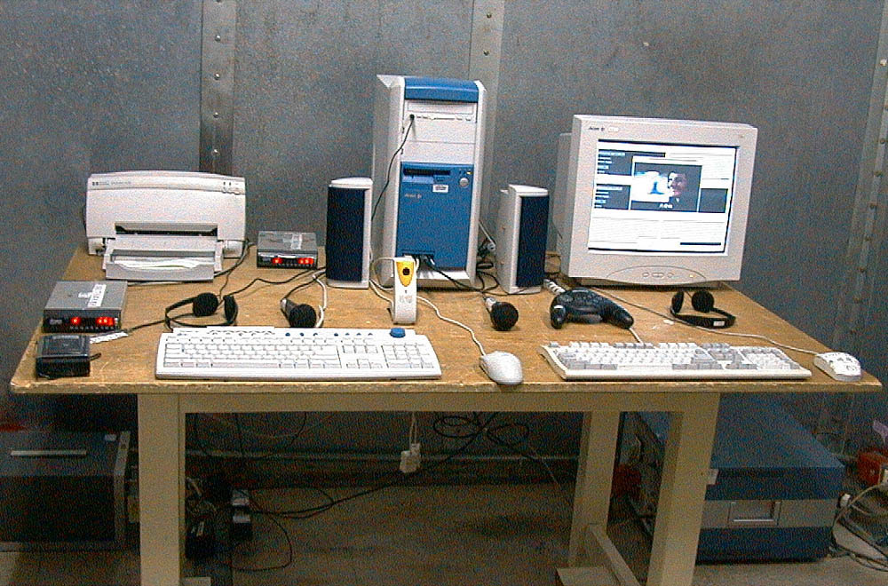
The Front View of Highest Radiated Set-up For EUT

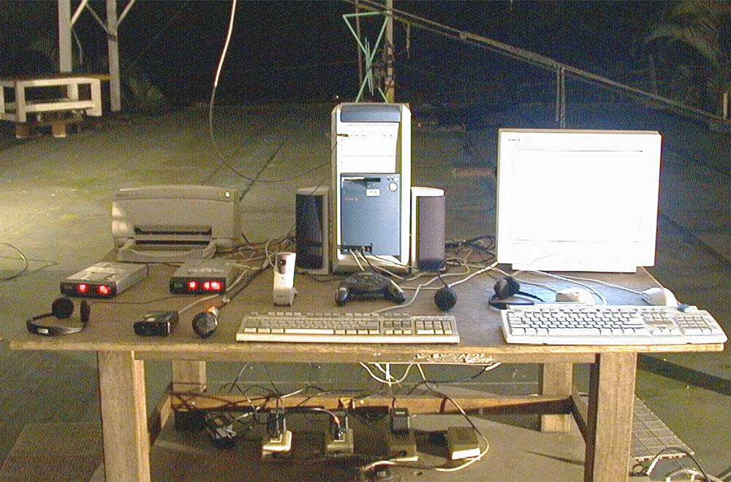

The Back View of Highest Radiated Set-up For EUT

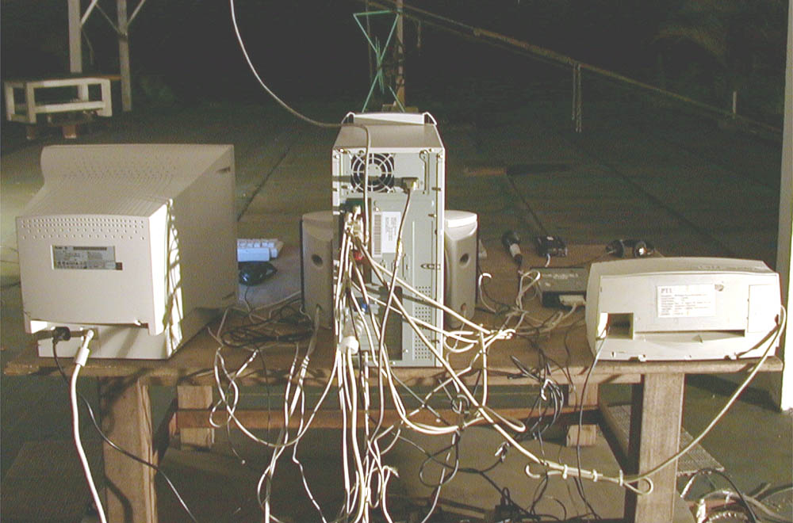

Appendix L: Photographs of EUT

Please find this appendix in the File of ISL-01A003P

